

**FPT ACADEMY INTERNATIONAL**

**FPT – APTECH COMPUTER EDUCATION**

**AIR HOUSE**

|  |  |  |
| --- | --- | --- |
| **Supervisor.** | **Lê Mộng Thúy** | |
| **Batch.** | **T1.2302.E1** | |
| **Group.** | **1** | |
| **Serial No.** | **Student Name** | **Enrollment Number** |
| **1** | **NGÔ ĐÌNH TÂN** | Student1455765 |
| **2** | **NGUYỄN THỊ NGỌC MAI** | Student1457506 |
| **3** | **NGUYỄN THÀNH NHÂN** | Student1455763 |
| **4** | **PHAN VĂN GIỮ** | Student1455761 |

**Month 12 Year 2023**

CONTENT

REVIEW 1 4

ACKNOWLEDGE 4

INTRODUCTION 4

PROBLEM DEFINITION 6

TASK SHEET REVIEW 1 10

REVIEW 2 12

1. USECASE 12

2. DATA FLOW DIAGRAM (DFD) 56

3. ENTITY RELATIONSHIP DIAGRAM (ERD) 64

4. TABLE DESIGN 65

Table structure for table amenities 65

Table structure for table blogs 65

Table structure for table blog_categories 65

Table structure for table blog_of_cate 65

Table structure for table bookings 66

Table structure for table categories 66

Table structure for table districts 66

Table structure for table failed_jobs 67

Table structure for table migrations 67

Table structure for table password_reset_tokens 67

Table structure for table personal_access_tokens 67

Table structure for table properties 68

Table structure for table property_amenities 69

Table structure for table property_exception_date 69

Table structure for table property_images 69

Table structure for table property_reviews 69

Table structure for table property_type 70

Table structure for table provinces 70

Table structure for table rating 70

Table structure for table room_type 70

Table structure for table tp_messages 71

Table structure for table transactions 71

Table structure for table users 72

5. TASK SHEET REVIEW 2 73

REVIEW 3 75

1. SITE MAP 75

2. AIRHOUSE WIREFRAME 76

3. AIRHOUSE SCREENSHOT 90

# REVIEW 1

## ACKNOWLEDGE

Our group would like to devote this chapter to express our sincere appreciation to all those who offered us v aluable assistance during in carrying out this Project.

Firstly, we owe a debt of gratitude to our dedicated instructor, MS. Le Mong Thuy, whose suggestions and encouragement helped us to overcome not only technological challenges but also psychological tension. Without him, our work could not complete successfully.

Secondly, we highly appreciate the Project Team at the Head Office, which has provided us an excellent opportunity to apply what we learned into practice. We are certain that the experiences we gained from this project will facilitate our future career greatly.

Thirdly, we would also like to express my gratitude to all the staff members of my center for not only providing me with the opportunity to work with them on this project, but also for their support and encouragement throughout the process.

Finally yet importantly, we wish to say a personal thank you to all our dear classmates and team members who are always willing to support us openly and enthusiastically.

## INTRODUCTION

In an era characterized by unprecedented levels of global mobility, where individuals traverse the world for various purposes such as leisure, professional engagements, or familial reunions, the necessity for temporary lodging has become increasingly pronounced. Recognizing this burgeoning need, Airhouse emerges as a sophisticated and indispensable stay booking service, specifically tailored to cater to the diverse and dynamic travel requirements of individuals within the vibrant landscape of Vietnam.

AirHouse is committed to serving the diverse needs of the travel community. Our customer base reflects the inclusivity of our platform, ensuring that everyone can find the perfect stay for their unique journey.

For Airhouse’s customer base:

* + Unregistered users who can register member account.
  + Registered users can login and manage their account.
  + Users can applying filters such as accommodation type, amenities, price range, and location.
  + Users can select their desired lodging, specify the duration of their stay, and proceed with a secure and efficient booking process.
  + Users can access comprehensive details about each property, including descriptions, amenities, photos, and customer reviews.
  + The website includes a platform for customers to leave reviews and feedback about their stay experiences
  + Users use the platform to create a listing for their property
  + Hosts can communicate with potential guests through the platform's messaging system
  + The platform provides hosts with tools to manage bookings effectively. This includes an intuitive calendar system to keep track of reservations
  + Airhouse handle the financial transactions between guests and hosts. Hosts can set their pricing, and payments are often processed securely through the platform
  + Hosts receive feedback and insights from guests, allowing them to continuously improve their hosting experience
  + Visitors can check out.
  + Visitors can review order history and make change.

## PROBLEM DEFINITION

After analyzing the project specifications of AirHouse, to fulfil customer’s requirements properly, we came to

conclusion that in order to achieve the best result, we should deal with following queries:

**FROM THE VIEW POINT OF USERS**

* + Display all properties based on various classifications
  + A comprehensive filtering system enables users to quickly find the desired property.
  + Users can log in and book the property of their choice.
  + Users can view their profile, booking history, and payment history.
  + Users can leave reviews and ratings for the properties they have experienced
  + User can become host

**FROM THE VIEW POINT OF HOST**

* + Hosts can view, add, update, and delete their properties
  + Booking Calendar Management: Hosts can manage the booking calendar for their own properties
  + Review Booking Requests: Hosts can review booking requests from users.
  + Save comments of users: Hosts can save comments about users.

**FROM THE VIEW POINT OF THE ADMINISTRATOR**

* + A login page will grant access to AirHouse admin system page.
  + Admin can view, add, update, delete and manage categories, amenities, room types, property types.
  + Manage all properties created by hosts, with the ability to accept or deny based on the admin's evaluation.

**CUSTOMER'S REQUIREMENTS SPECIFICATIONS (CRS) CLIENT: AIRHOUSE**

**BUSINESS/PROJECT OBJECTIVE:**

Airhouse aims to provide a user-friendly platform for property hosts and guests, facilitating seamless property management, booking, and review processes.

**INPUT TO THE SYSTEM:**

**AirHouse administrators need to provide:**

* + Information required in order to create property(amentites, categories, room types, property types).
  + Acception for property to show in the website..
  + Information required to create other admin account within admin system.
  + Manage (view, add, update, delete) news

**Users AirHouse need to provide:**

* + Personal information to book property
  + Email information for user authentication.

**OUTPUT FROM THE SYSTEM:**

**AirHouse host will be able to:**

* + Manage (view, add, update, delete, hidden) property.
  + Manage (accept, deny) booking .
  + Manage (view, add, update) products, order.

**AirHouse guests will be able to:**

* + Register customer account.
  + Booking property after add information.
  + View property that they have chosen.
  + View booking history.

**Liquor Stores customer will be able to:**

* + Register account.
  + Login/Logout to the account.
  + Filter property they want to book by check-in, check-out date, price, amenities, categories, property types.
  + Booking property.
  + View booking history.

**SCOPE OF WORK**

The application should perform the following functions:

**LOGIN:**

* + There are 3 types of account in the application (“admin”). Administrator will login as “admin”. User can create their own property to become (“host”) or they can just be guest if they do not own any property and Host can login as “host” and “user”.
  + For “admin”: can view the property id, name, accept or deny host property.
  + For “host”: can view and manage booking.

**ORDERING PRODUCTS:**

* + When customer book a property and the booked property will be added to the Booked list.
  + Customer can complete payment at Booked List after fill in their payment information.

**DATABASE:**

* + The information about amenities, properties, categories, properties type, blog, blog categories, property, user will be stored in the database.
  + The information from the contact us page.

**HARDWARE/ SOFTWARE REQUIREMENTS:**

**HARDWARE**

**Web Server**

|  |  |
| --- | --- |
| **Processor** | Intel Core I7 or higher. |
| **Memory** | 32 GB RAM or greater. |
| **Modem/ADSL** | Internet access is required. |

**Client**

|  |  |
| --- | --- |
| **Processor** | Intel Core I5 or higher. |
| **Memory** | 8 GB RAM or greater. |
| **Monitor** | Super VGA (1024x768) or higher resolution. |
| **Modem/ADSL** | Internet access is required. |

**SOFTWARE**

**Web Server**

|  |  |
| --- | --- |
| **Operation System** | Window 7 or later. |
| **Browser** | Google Chrome version 35. |
| **Database** | MySQL. |
| **Software** | Internet Information Service |
| PHP - Laravel framework |

**Client**

|  |  |
| --- | --- |
| **Operation System** | Window 7 or higher. |
| **Browser** | Google Chrome version 35. |

**DEVELOPMENT SOFTWARE**

* + Microsoft Windows 10.
  + MySQL.
  + Visual Studio Code.
  + Google Chrome.
  + XAMPP.

**TECHNOLOGY**

* + PHP - Laravel framework.
  + React.
  + React-Query
  + Styled Components

.

## TASK SHEET REVIEW 1

|  |  |  |  |  |  |  |  |
| --- | --- | --- | --- | --- | --- | --- | --- |
| **Project: Liquor Stores** | | **Project Name** | **Activity Plan Prepared By** | **Date of Preparation of Activity Plan:** | | | |
| **Sr./No.** | **Task** | **Actual Start Date** | **Actual Days** | **Team member name** | **Status** |
| **1** | **Acknowledgment** | **Air**  **House** | Tân | 13-Dec-  23 | 1 | Tân | Completed |
| **2** | **Introduction** | 13-Dec-  23 | 1 | Tân | Completed |
| **3** | **Problem Definition** | 13-Dec-  23 | 1 | Tân | Completed |
| **4** | **Customer Requirement Specification (CRS)** | 13-Dec-  23 | 1 | Tân | Completed |

|  |  |  |  |  |  |  |  |  |  |
| --- | --- | --- | --- | --- | --- | --- | --- | --- | --- |
| **5** | **Scope of Work** |  |  | | 13-Dec-  23 | 1 | Mai | Completed | |
| **6** | **Hardware/Software Requirement** | 13-Dec-  23 | 1 | Mai | Completed | |
| **7** | **Task Sheet** | 13-Dec-  23 | 1 | Mai | Completed | |
| Date: 13 DECEMBER 2023 | | | | | | | | |  |
| **Signature of Instructor:**  **Ms. LE MONG THUY** | | | | **Signature of Team Leader:**  **NGÔ ĐÌNH TÂN** | | | | |  |

# REVIEW 2

## USECASE

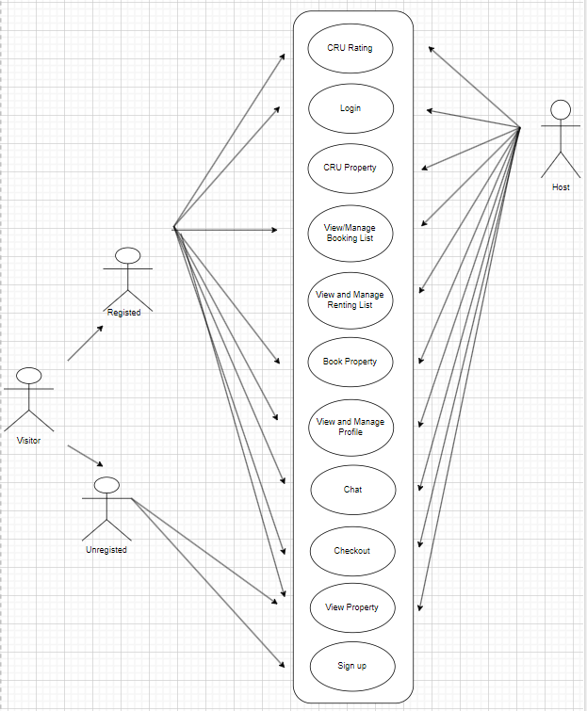

**VISITOR**

**LOGIN AS VISITOR:**

|  |  |  |  |  |  |  |
| --- | --- | --- | --- | --- | --- | --- |
| **Author** |  | | | | | |
| **Use Case Name** | Login as User | | | | | |
| **Actors** | Visitor | | | | | |
| **Description** | Visitor who has registed an account can login | | | | | |
| **Requirements** | Visitor provides username and password | | | | | |
| **Pre-conditions** | Visitor must register an account | | | | | |
| **Post-conditions** | Success: User is logged in to website | | | | | |
| Fail: Refill information | | | | | |
|  | **Actor’s actions:** | | | | | **System’s responses:** |
|  | 1. Visitor clicks ‘Continue’ button on Home  Page. | | | | | 2. System shows Login Form Popup with the following controls: |
|  |  | | | | | - “Email” text field |
| **Basic flow** |  | | | | | - “Password” text field |
|  |  | | | | | - “Continue” button |
|  | 3. Actor inputs Email and Password,  then click the ‘Continue’ button. | | | | | 4. System checks the information. |
|  |  | | | | | 5. System turn off the Popup |
| **Exceptions** | **Actor’s actions:** | | | | | **System’s responses:** |
| 1. Actor password. | inputs | invalid | email | and | System shows Login Form Popup with the following controls:  - “Email” text field |

|  |  |  |
| --- | --- | --- |
|  |  | * “Password” text field * “Continue” button   System shows message: “Invalid email or password”. |

**REGISTER AS USER:**

|  |  |  |
| --- | --- | --- |
| **Author** |  | |
| **Use Case Name** | Register as User | |
| **Actors** | Visitor | |
| **Description** | All visitors who have a valid email can register | |
| **Requirements** | Visitor registers an account on the website and becomes a user | |
| **Pre-conditions** | Visitor provides their register information | |
| **Post-conditions** | Success: Visitor creates an User account on this website | |
| Fail: Refill information | |
| **Basic flow** | **Actor’s actions:** | **System’s responses:** |
| 1. Visitor clicks “Sign up” button on  Home Page. | 2. System shows Sign Up Popup with the following controls:   * “Password” text field * “Confirm Password” text field * “Email” text field * “First Name” text field * “Last Name” text field |

|  |  |  |
| --- | --- | --- |
|  | 3. Visitor inputs register’s information and click “Finish” button. | * “Finish” button  1. System validates the information. 2. System inserts the account into database 3. System show success message. |
| **Exceptions** | **Actor’s actions:** | **System’s responses:** |
| * Actor enter registered email. * Actor left “Email” text field blank * Actor left “Password” text field blank. * Actor enter Password under 9 characters * Actor left “Confirm Password” text   field blank.   * Actor enter wrong Password Confirmation * Actor left “First Name” text field blank * Actor left “Last Name” text field blank | System displays message to customer:   * “Email has already existed”. * “Email cannot be blank * “Password cannot be blank” * “Password must have at least 9 characters” * “Confirm Password cannot be blank”. * “Wrong password confirmation” * “First Name is required * “Last Name is required”. |

**FILTER PROPERTIES:**

|  |  |  |
| --- | --- | --- |
| **Author** |  | |
| **Use case name** | Filter Property | |
| **Actors** | Registered User/ Visitor | |
| **Description** | Actors can filter property | |
| **Requirements** | Actors provides filter condition | |
| **Pre-conditions** | N/A | |
| **Post-conditions** | Success: Show property that matches filter condition | |
| Fail: No property is shown | |
| **Basic flow** | **Actor’s actions:** | **System’s responses:** |
| 1. Actor choose filter conditions.  3. Actor clicks properties’ name in list or view every properties that match filter conditions. | 2. System shows list of properties that match the filter conditions. |

**VIEW PROPERTY DETAIL:**

|  |  |  |
| --- | --- | --- |
| **Author** |  | |
| **Use case name** | View property detail | |
| **Actors** | Registered User/ Visitor | |
| **Description** | Actors can view property detail | |
| **Requirements** | Actors select property to show property’s detail | |
| **Pre-conditions** | N/A | |
| **Post-conditions** | Success: Display property detail matching the selected property | |
| Fail: No product is shown | |
| **Basic flow** | **Actor’s actions:** | **System’s responses:** |
| 1. Actor select property | 2. System shows property’s detail  matching selected property |

**PLACING BOOKING:**

|  |  |  |
| --- | --- | --- |
| **Author** |  | |
| **Use case name** | Place booking | |
| **Actors** | Registered users | |
| **Description** | Users can place their booking. | |
| **Requirements** | Users must choose at least one property | |
| **Pre-conditions** | Users must log in before placing their booking | |
| **Post-conditions** | Success: Users place their booking successfully | |
| Fail: Follow property’s requirement and book again | |
| **Basic flow** | **Actor’s actions:** | **System’s responses:** |
| 1. Actor chooses a property, booking dates, number of guests and click  “Continue”. | 2. System redirects to Payment page if property’s booking type is “instantly”, or to Actor’s Booking List page to wait for Host’s confirmation. |

|  |  |  |
| --- | --- | --- |
| **Exceptions** | **Actor’s action** | **System’s response** |
| 1.Actor select number of dates to stay out of range. | 2. System shows messages:  - “Range book date from…to…” |

**Create Property:**

|  |  |  |
| --- | --- | --- |
| **Author** |  | |
| **Use case name** | Create property | |
| **Actors** | Registed users | |
| **Description** | Registed users can create property | |
| **Requirements** | Email verified | |
| **Pre-conditions** | Users must log in before create property | |
| **Post-conditions** | Success: Users can create property successfully | |
| Fail: Refill information | |
| **Basic flow** | **Actor’s actions:** | **System’s responses:** |
| 1. Actor click on “Become a host” button. 2. Actor fill in create property form, click “Finish” button. | 1. System redirects become host page.   2. System show Success alert and redirects to My Listing page. |
| **Exceptions** | **Actor’s action** | **System’s response** |
| 1. Left required field blank | 1. Show required messege |

**Update Property:**

|  |  |  |
| --- | --- | --- |
| **Author** |  | |
| **Use case name** | Update property | |
| **Actors** | Registed users | |
| **Description** | Registed users can update property | |
| **Requirements** | Registed users owned that property | |
| **Pre-conditions** | Users must log in before update property | |
| **Post-conditions** | Success: Users can update property successfully | |
| Fail: Refill information | |
| **Basic flow** | **Actor’s actions:** | **System’s responses:** |
| 1. Actor click on “Listing” button in Profile dropdown. 2. Actor click on “Edit” button belongs to certain property. | 1. System redirects to My Listing page.   2. System redirects to Update form page. |
| **Exceptions** | **Actor’s action** | **System’s response** |
| 1. Left required field blank | 1. Show required messege |

**CHECKOUT:**

|  |  |  |
| --- | --- | --- |
| **Author** |  | |
| **Use case name** | Check out | |
| **Actors** | Registered users | |
| **Description** | Registered users can pay for the booking | |
| **Requirements** | Registered user must place their booking successfully first. | |
| **Pre-conditions** | Registered user must log in before checkout | |
| **Post-conditions** | Success: Registered user order successfully | |
| Fail: Refill information | |
| **Basic flow** | **Actor’s actions:** | **System’s responses:** |
|  | 1. Actor fill in payment form and click “Pay now” button | 1. System redirects to Payment Success page. |
| **Exceptions** | **Actor’s action** | **System’s response** |
|  | System shows messages: |
| 1. Actor inputs invalid card number. | 1. “Your card number is invalid.” |
| 1. Actor left “Expiration” text field   blank. | 1. “Your card's expiration date is incomplete.” |
| 1. Actor inputs invalid Expiration. | 1. “Your card's expiration year is invalid.” |
| 1. Actor left “CVC” blank. | 1. “Your card's security code is incomplete.” |
| 1. Actor inputs invalid CVC. | 1. “Your card's expiration year is invalid.” |

**VIEW BOOKING LIST**

|  |  |  |
| --- | --- | --- |
| **Author** |  | |
| **Use case name** | View booking list | |
| **Actors** | Registed users/Host | |
| **Description** | Actor can view booking list | |
| **Requirements** | Actor must have at least one booking record | |
| **Pre-conditions** | Actor must log in to website | |
| **Post-conditions** | Actor can view their booking list. | |
| Fail: Actor cannot see their booking list. | |
| **Basic flow** | **Actor’s actions:** | **System’s responses:** |
|  | 1. Actor click “Listing” button in Profile dropdown | 2. System redirects to Listing page. |
|  | 1. Actor click “My Booking” tab | 2. System show actor’s booking list |

**MANAGE BOOKING LIST**

|  |  |  |
| --- | --- | --- |
| **Author** |  | |
| **Use case name** | Manage booking from user | |
| **Actors** | Host | |
| **Description** | Actor can accept a booking and waiting for pay or deny a booking | |
| **Requirements** | At least one property has been booked to perform | |
| **Pre-conditions** | Perform Accept,Deny action then it saved into databse | |
| **Post-conditions** | Registed can see booking status is accept,deny | |
| Fail: Status booking is Deny or Expired | |
| **Basic flow** | **Actor’s actions:** | **System’s responses:** |
|  | 1. Host click Accep,Deny to certaint Booking | 1. System show the alert ‘succes’ |
|  |  |  |

**CHAT**

|  |  |  |
| --- | --- | --- |
| **Author** |  | |
| **Use case name** | Chat | |
| **Actors** | Registed, Host | |
| **Description** | Registed can chat to host about their booking | |
| **Requirements** | Have at least 1 booking | |
| **Pre-conditions** | Registed must login | |
| **Post-conditions** | Message information has been saved into database | |
| Host receives the message and response | |
| **Basic flow** | **Actor’s actions:** | **System’s responses:** |
|  | 1. Registed go to Booking-List page and click ‘Send Message’ | 1. When Host online, can respone the message again to Register |
|  | 1. Registed receive Host’ response |  |

**VIEW AND MANAGE PROFILE**

|  |  |  |
| --- | --- | --- |
| **Author** |  | |
| **Use case name** | View and Manage Profile | |
| **Actors** | Host,Registed | |
| **Description** | Change actors’s information like first name, last name, address, phone number | |
| **Requirements** | Actor must log in to webiste | |
| **Pre-conditions** | Change information in field then it saved into database | |
| **Post-conditions** | See what is changed in ‘Dashboard’ page | |
| Fail: Information has not been saved | |
| **Basic flow** | **Actor’s actions:** | **System’s responses:** |
|  | 1. Go to ‘Edit Profile’ or ‘Profile Photo’ and input into field | 1. System show the alert ‘succes’ |
|  | 1. Go to ‘Dashboard’ to see Actor Profile |  |

**VIEW RENTINGS**

|  |  |  |
| --- | --- | --- |
| **Author** |  | |
| **Use case name** | View renting | |
| **Actors** | Registed users/Host | |
| **Description** | Actor can view rentings list | |
| **Requirements** | Actor must have at least owner property | |
| **Pre-conditions** | Actor must log in to website | |
| **Post-conditions** | Actor can view their renting list. | |
| Fail: Actor cannot see their reting list. | |
| **Basic flow** | **Actor’s actions:** | **System’s responses:** |
|  | 1. Actor click “Dashboard” button in Profile dropdown | 2. System redirects to My Rentings page. |
|  |  |  |

**MANAGER ACCEPT RENTINGS**

|  |  |  |
| --- | --- | --- |
| **Author** |  | |
| **Use case name** | Accept bookings of renter | |
| **Actors** | Registed users/Host | |
| **Description** | Actor can accept bookings of renter | |
| **Requirements** | Actor must have at least owner property | |
| **Pre-conditions** | Actor must log in to website | |
| **Post-conditions** | Actor can manager renting list. | |
| Fail: Actor cannot manager their rentings list. | |
| **Basic flow** | **Actor’s actions:** | **System’s responses:** |
|  | 1. Actor click “Dashboard” button in Profile dropdown | 2. System redirects to My Rentings page. |
|  | 1. Actor click “Accept” button | 2. System process accept bookings of renter |

**MANAGER DENY RENTINGS**

|  |  |  |
| --- | --- | --- |
| **Author** |  | |
| **Use case name** | Deny bookings of renter | |
| **Actors** | Registed users/Host | |
| **Description** | Actor can deny bookings of renter | |
| **Requirements** | Actor must have at least owner property | |
| **Pre-conditions** | Actor must log in to website | |
| **Post-conditions** | Actor can manager renting list. | |
| Fail: Actor cannot manager their rentings list. | |
| **Basic flow** | **Actor’s actions:** | **System’s responses:** |
|  | 1. Actor click “Dashboard” button in Profile dropdown | 2. System redirects to My Rentings page. |
|  | 1. Actor click “Deny” button | 2. System process deny bookings of renter |

**CREATE RATING ABOUT PROPERTY**

|  |  |  |
| --- | --- | --- |
| **Author** |  | |
| **Use case name** | Create rating | |
| **Actors** | Registed users/Host | |
| **Description** | Actor can cretae rate about property | |
| **Requirements** | Actor must have at least one booking of the property | |
| **Pre-conditions** | Actor must log in to website | |
| **Post-conditions** | Actor must have a rating for this property beforehand | |
| Fail: Actor cannot update rating. | |
| **Basic flow** | **Actor’s actions:** | **System’s responses:** |
|  | 1. Actor click “Dashboard” button in Profile dropdown | 2. System redirects to My Bookings list page. |
|  | 1. Actor click “Accepted” button   1. Actor click “property image” that want to rating   1. Rating and coment then click vote or enter | 2. System show list accepted booking   1. System redirects to property   Information.  2. System post rating and comment. |

**UPDATE RATING ABOUT PROPERTY**

|  |  |  |
| --- | --- | --- |
| **Author** |  | |
| **Use case name** | Update rating | |
| **Actors** | Registed users/Host | |
| **Description** | Actor can update rating about property | |
| **Requirements** | Actor must have at least one booking of the property | |
| **Pre-conditions** | Actor must log in to website | |
| **Post-conditions** | Actor have to enter comment and rating. | |
| Fail: Actor cannot update rating. | |
| **Basic flow** | **Actor’s actions:** | **System’s responses:** |
|  | 1.Actor click “Dashboard” button in Profile dropdown | 2. System redirects to My Bookings list page. |
|  | 1. Actor click “Accepted” button  1. Actor click “property image” that want to rating  1. Rating and coment then click vote or enter | 2. System show list accepted booking  2.System redirects to property  Information.  2. System post rating and comment. |

**READ ALL RATING ABOUT PROPERTY**

|  |  |  |
| --- | --- | --- |
| **Author** |  | |
| **Use case name** | Read all rating | |
| **Actors** | Visitor | |
| **Description** | Actor can see all rating about property | |
| **Requirements** | Actor must have click one whatever property | |
| **Pre-conditions** | Not pre-conditions | |
| **Post-conditions** | Actor can see all rating about property. | |
| Fail: Actor cannot see all rating about property. | |
| **Basic flow** | **Actor’s actions:** | **System’s responses:** |
|  | 1. Actor click one whatever property | 2. System redirects to property informatin page. |
|  |  |  |

**CREATE RATING ABOUT USER**

|  |  |  |
| --- | --- | --- |
| **Author** |  | |
| **Use case name** | Create rating | |
| **Actors** | Registed users/Host | |
| **Description** | Actor can create rate about user | |
| **Requirements** | User must have at least one booking of the property that actor’s | |
| **Pre-conditions** | Actor must log in to website | |
| **Post-conditions** | Actor rating and enter comment about user | |
| Fail: Actor cannot create rating. | |
| **Basic flow** | **Actor’s actions:** | **System’s responses:** |
|  | 1.Actor click “Dashboard” button in Profile dropdown | 2. System redirects to My Rentings page. |
|  | 1. Actor click “Rating” button  1.Actor click “submit” that want to rating | 2. System show popup for rating  2.System post rating |

**UPDATE RATING ABOUT USER**

|  |  |  |
| --- | --- | --- |
| **Author** |  | |
| **Use case name** | Update rating | |
| **Actors** | Registed users/Host | |
| **Description** | Actor can update rate about user | |
| **Requirements** | User must have at least one booking of the property that actor’s | |
| **Pre-conditions** | Actor must log in to website | |
| **Post-conditions** | Actor have to enter comment and rating. | |
| Fail: Actor cannot update rating. | |
| **Basic flow** | **Actor’s actions:** | **System’s responses:** |
|  | 1.Actor click “Dashboard” button in Profile dropdown | 2. System redirects to My Rentings page. |
|  | 1. Actor click “Rating” button  1.Actor click “submit” that want to rating | 2. System show popup for rating  2.System update rating |

**READ ALL RATING ABOUT PROPERTY**

|  |  |  |
| --- | --- | --- |
| **Author** |  | |
| **Use case name** | Read all rating | |
| **Actors** | Visitor | |
| **Description** | Actor can see all rating about user | |
| **Requirements** | Actor must have click one whatever property | |
| **Pre-conditions** | Not pre-conditions | |
| **Post-conditions** | Actor can see all rating about property. | |
| Fail: Actor cannot see all rating about property. | |
| **Basic flow** | **Actor’s actions:** | **System’s responses:** |
|  | 1. Actor click one whatever property   1. Click “Avatar” of user/host  1. Click “Review from hosts” button | 2. System redirects to property informatin page.  2. System redirects to profile detail of user/host  2. System show all rating about user/host |
|  |  |  |

**ADMIN**

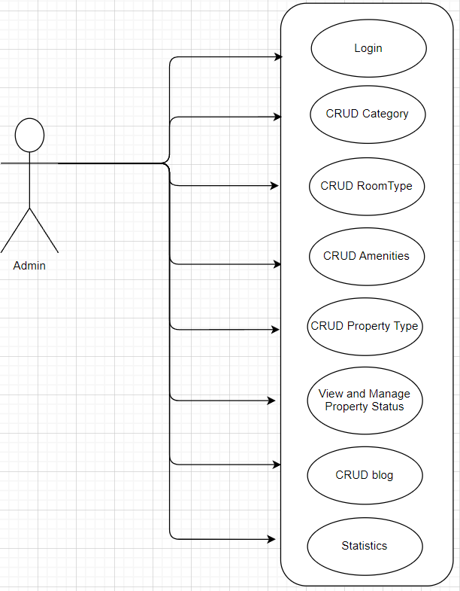

**LOGIN**

|  |  |  |
| --- | --- | --- |
| **Author** |  | |
| **Use case name** | Login | |
| **Actor** | Admin | |
| **Description** | When admin wants to manage products, news, views orders and orders detail | |
| **Requirements** | Admin provides username and password | |
| **Pre-conditions** | Admin must be exist on database | |
| **Post-conditions** | Success: Admin is logged in to website admin | |
| Fail: refill information | |
| **Basic flow** | **Actor’s actions:** | **System’s responses:** |
| 3. Actor inputs Email and Password,  then click the ‘Login’ button. | 1. System validates the information. 2. System redirects to Admin website |
| **Exceptions** | **Actor’s actions:** | **System’s responses:** |
| 1. Actor inputs invalid email and password | System redirects to Login page with the following controls:   * ‘Email’ text field * ‘Password’ text field * ‘Login’ button. |

**CREATE BLOG CATEGORY:**

|  |  |
| --- | --- |
| **Author** |  |
| **Use case name** | Create blog category |
| **Actors** | Admin |
| **Description** | Admin can create blog category |
| **Requirements** | Admin provides blog category’s information |
| **Pre-conditions** | Actor must log in as administrator first |

|  |  |  |
| --- | --- | --- |
| **Post-conditions** | Success: Create successfully. | |
|  | |
| **Basic flow** | **Actor’s actions:** | **System’s responses:** |
|  | 1. Actor click “Create New Category” | 1. System show Create Popup |
|  | 1. Actor fill in form and click “Submit” | 1. System alert “Success” |

**UPDATE BLOG CATEGORY:**

|  |  |
| --- | --- |
| **Author** |  |
| **Use case name** | Update blog category |
| **Actors** | Admin |
| **Description** | Admin can update blog category |
| **Requirements** | Admin provides blog category’s information |
| **Pre-conditions** | The blog category has to be existed already |

|  |  |  |
| --- | --- | --- |
| **Post-conditions** | Success: Update successfully. | |
|  | |
| **Basic flow** | **Actor’s actions:** | **System’s responses:** |
|  | 1. Actor click “Update” button | 1. System show Update Popup |
|  | 1. Actor fill in form and click “Submit” | 1. System alert “Success” |

**DELETE BLOG CATEGORY:**

|  |  |
| --- | --- |
| **Author** |  |
| **Use case name** | Delete blog category |

|  |  |  |
| --- | --- | --- |
| **Actor** | Admin | |
| **Description** | Admin can delete | |
| **Requirements** | Blogs belonging to the particular blog category have to be deteled in advanced | |
| **Pre-conditions** | Actor must log in as administrator first | |
| **Post-conditions** | Success: blog category is delete in the database | |
| Fail: blog category is not delete from the database | |
| **Basic flow** | **Actor’s actions:** | **System’s responses:** |
|  | 1. Actor clicks ‘Delete’ button. | 1. System displays confirmation |
| 1. Actor clicks ‘OK’ | 1. System delete blog category in the database |

**CREATE AMENITIES**

|  |  |  |
| --- | --- | --- |
| **Author** |  | |
| **Use case name** | Cretae amenity | |
| **Actors** | Admin | |
| **Description** | Actor can create amenity | |
| **Requirements** | Actor must log in website | |
| **Pre-conditions** | Not pre-conditions | |
| **Post-conditions** | Enter amenity. | |
| Fail: Actor cannot create amenity. | |
| **Basic flow** | **Actor’s actions:** | **System’s responses:** |
|  | 1. Enter url /admin  1. Actor click “Type” button then click “Amenities” in aside nav bar   1. Actor click “Create new amenity”   1. Actor click “Submit” of user/host | 2. Sytem redirect to Admin page  2. System redirect to Amenity page  2. System show popup for enter amenity  2. System post amenity |
|  |  |  |

**UPDATE AMENITIES**

|  |  |  |
| --- | --- | --- |
| **Author** |  | |
| **Use case name** | Update amenity | |
| **Actors** | Admin | |
| **Description** | Actor can update amenity | |
| **Requirements** | Actor must log in website | |
| **Pre-conditions** | Actor must have at least amenity | |
| **Post-conditions** | Enter amenity. | |
| Fail: Actor cannot update amenity. | |
| **Basic flow** | **Actor’s actions:** | **System’s responses:** |
|  | 1. Enter url /admin  1. Actor click “Type” button then click “Amenities” in aside nav bar   1. Actor click setting icon   1. Actor click “Submit” of user/host | 2. System redirect Admin page  2. System redirect to Amenity page  2. System show popup for enter amenity  2. System update amenity |
|  |  |  |

**READ AMENITIES**

|  |  |  |
| --- | --- | --- |
| **Author** |  | |
| **Use case name** | Read amenity | |
| **Actors** | Admin | |
| **Description** | Actor can read all amenity | |
| **Requirements** | Actor must log in website | |
| **Pre-conditions** | Not pre-conditions | |
| **Post-conditions** | Not post-consitions | |
| Fail: Actor cannot see amenity. | |
| **Basic flow** | **Actor’s actions:** | **System’s responses:** |
|  | 1. Enter url /admin  1. Actor click “Type” button then click “Amenities” in aside nav bar | 2. System redirect Admin page  2. System redirect to Amenity page |
|  |  |  |

**DELETE AMENITIES**

|  |  |  |
| --- | --- | --- |
| **Author** |  | |
| **Use case name** | Delete amenity | |
| **Actors** | Admin | |
| **Description** | Actor can delete amenity | |
| **Requirements** | Actor must log in website | |
| **Pre-conditions** | Actor must have at least amenity | |
| **Post-conditions** | Actor click icon delete | |
| Fail: Actor cannot delete amenity. | |
| **Basic flow** | **Actor’s actions:** | **System’s responses:** |
|  | 1. Enter url /admin  1. Actor click “Type” button then click “Amenities” in aside nav bar   1. Actor click delete icon | 2. System redirect Admin page  2. System redirect to Amenity page  2. System process amenity delete request |
|  |  |  |

**CREATE AMENITIES**

|  |  |  |
| --- | --- | --- |
| **Author** |  | |
| **Use case name** | Cretae amenity | |
| **Actors** | Admin | |
| **Description** | Actor can create amenity | |
| **Requirements** | Actor must log in website | |
| **Pre-conditions** | Not pre-conditions | |
| **Post-conditions** | Enter amenity. | |
| Fail: Actor cannot create amenity. | |
| **Basic flow** | **Actor’s actions:** | **System’s responses:** |
|  | 1. Enter url /admin  1. Actor click “Type” button then click “Amenities” in aside nav bar   1. Actor click “Create new amenity”   1. Actor click “Submit” of user/host | 2. Sytem redirect to Admin page  2. System redirect to Amenity page  2. System show popup for enter amenity  2. System post amenity |
|  |  |  |

**UPDATE AMENITIES**

|  |  |  |
| --- | --- | --- |
| **Author** |  | |
| **Use case name** | Update amenity | |
| **Actors** | Admin | |
| **Description** | Actor can update amenity | |
| **Requirements** | Actor must log in website | |
| **Pre-conditions** | Actor must have at least amenity | |
| **Post-conditions** | Enter amenity. | |
| Fail: Actor cannot update amenity. | |
| **Basic flow** | **Actor’s actions:** | **System’s responses:** |
|  | 1. Enter url /admin  1. Actor click “Type” button then click “Amenities” in aside nav bar   1. Actor click setting icon   1. Actor click “Submit” of user/host | 2. System redirect Admin page  2. System redirect to Amenity page  2. System show popup for enter amenity  2. System update amenity |
|  |  |  |

**READ AMENITIES**

|  |  |  |
| --- | --- | --- |
| **Author** |  | |
| **Use case name** | Read amenity | |
| **Actors** | Admin | |
| **Description** | Actor can read all amenity | |
| **Requirements** | Actor must log in website | |
| **Pre-conditions** | Not pre-conditions | |
| **Post-conditions** | Not post-consitions | |
| Fail: Actor cannot see amenity. | |
| **Basic flow** | **Actor’s actions:** | **System’s responses:** |
|  | 1. Enter url /admin  1. Actor click “Type” button then click “Amenities” in aside nav bar | 2. System redirect Admin page  2. System redirect to Amenity page |
|  |  |  |

**DELETE AMENITIES**

|  |  |  |
| --- | --- | --- |
| **Author** |  | |
| **Use case name** | Delete amenity | |
| **Actors** | Admin | |
| **Description** | Actor can delete amenity | |
| **Requirements** | Actor must log in website | |
| **Pre-conditions** | Actor must have at least amenity | |
| **Post-conditions** | Actor click icon delete | |
| Fail: Actor cannot delete amenity. | |
| **Basic flow** | **Actor’s actions:** | **System’s responses:** |
|  | 1. Enter url /admin  1. Actor click “Type” button then click “Amenities” in aside nav bar   1. Actor click delete icon | 2. System redirect Admin page  2. System redirect to Amenity page  2. System process amenity delete request |
|  |  |  |

**CREATE BLOG**

|  |  |  |
| --- | --- | --- |
| **Author** |  | |
| **Use case name** | Create Blog | |
| **Actors** | Admin | |
| **Description** | Actor can create blog | |
| **Requirements** | Actor must log in website | |
| **Pre-conditions** | Not Pre-conditions | |
| **Post-conditions** | Actor enter blog and submit | |
| Fail: Actor cannot create blog. | |
| **Basic flow** | **Actor’s actions:** | **System’s responses:** |
|  | 1. Enter url /admin        1. Actor click “Blog” in aside nav bar   1. Actor click "create new blog” button   1. Actor click “click” submit | 2. System redirect Admin page   2. System redirect to Blog page  2. System show form create blog    2. System post new blog |
|  |  |  |

**UPDATE BLOG**

|  |  |  |
| --- | --- | --- |
| **Author** |  | |
| **Use case name** | Update Blog | |
| **Actors** | Admin | |
| **Description** | Actor can update blog | |
| **Requirements** | Actor must log in website | |
| **Pre-conditions** | Actor must have at least blog | |
| **Post-conditions** | Actor enter blog and submit | |
| Fail: Actor cannot update blog. | |
| **Basic flow** | **Actor’s actions:** | **System’s responses:** |
|  | 1. Enter url /admin        1. Actor click “Blog” in aside nav bar  1. Actor click "setting” icon   1. Actor click "submit” button | 2. System redirect Admin page   2. System redirect to Blog page  2. System show form update blog  2. System update blog |
|  |  |  |

**READ BLOG**

|  |  |  |
| --- | --- | --- |
| **Author** |  | |
| **Use case name** | Read Blog | |
| **Actors** | Admin | |
| **Description** | Actor can read blog | |
| **Requirements** | Actor must log in website | |
| **Pre-conditions** | Non Pre-conditions | |
| **Post-conditions** | Non Post-conditions | |
| Fail: Actor cannot update blog. | |
| **Basic flow** | **Actor’s actions:** | **System’s responses:** |
|  | 1. Enter url /admin        1. Actor click “Blog” in aside nav bar | 2. System redirect Admin page   2. System redirect to Blog page |
|  |  |  |

**DELETE BLOG**

|  |  |  |
| --- | --- | --- |
| **Author** |  | |
| **Use case name** | Delete Blog | |
| **Actors** | Admin | |
| **Description** | Actor can delete blog | |
| **Requirements** | Actor must log in website | |
| **Pre-conditions** | Actor must have at least blog | |
| **Post-conditions** | Non Post-conditions | |
| Fail: Actor cannot delete blog. | |
| **Basic flow** | **Actor’s actions:** | **System’s responses:** |
|  | 1. Enter url /admin        1. Actor click “Blog” in aside nav bar   1. Actor click delete icon | 2. System redirect Admin page   2. System redirect to blog page  2. System process blog delete request |
|  |  |  |

**VIEW SITE STATISTICS:**

|  |  |  |
| --- | --- | --- |
| **Author** |  | |
| **Use case name** | View Site Statistics | |
| **Actors** | Admin | |
| **Description** | Actors can access site statistics such as revenue, booking counts, and category distribution for each province. Additionally, they can view the number of provinces associated with each category. | |
| **Requirements** | Actors provides filter condition | |
| **Pre-conditions** | Users must login as admin | |
| **Post-conditions** | Success: Show statistics that matches filter condition | |
| Fail: Nothing is shown | |
| **Basic flow** | **Actor’s actions:** | **System’s responses:** |
| 1. Actor choose filter conditions. | 2. The system presents statistical charts that reflect the filtered conditions chosen by the actor. |

**VIEW AND MANAGE PROPERTY STATUS:**

|  |  |  |
| --- | --- | --- |
| **Author** |  | |
| **Use case name** | View and Manage property listing status | |
| **Actors** | Admin | |
| **Description** | Actors can access site properties, apply multiple filters, view detailed information for each property, and respond to property listing requests by either accepting or denying them. | |
| **Requirements** | Actors provides filter condition | |
| **Pre-conditions** | Users must login as admin | |
| **Post-conditions** | Success: Show property that matches filter condition, accept or deny listing request | |
| Fail: Nothing is shown | |
| **Basic flow** | **Actor’s actions:** | **System’s responses:** |
| 1. Actor choose filter conditions. 2. Actor All or In Waiting, Error, Success 3. Actor can search properties based on name or id 4. Actor click property 5. Actor can accept or deny that property listing request | 1. The system show property that fits filter conditions. 2. The system show property that fit these status 3. The system displays properties with matching names and IDs based on the specified criteria. 4. The system show that property detail info 5. The system send mail to host |
| **Exception** | **Actor’s actions:** | **System’s responses:** |
| 1. Actor click deny with out leave a message for host | 1. The system alert error |

**CREATE CATEGORY**

|  |  |  |
| --- | --- | --- |
| **Author** |  | |
| **Use case name** | Create category | |
| **Actors** | Admin | |
| **Description** | Actor can create category | |
| **Requirements** | Actor must log in website | |
| **Pre-conditions** | Not pre-conditions | |
| **Post-conditions** | Enter category. | |
| Fail: Actor cannot create category. | |
| **Basic flow** | **Actor’s actions:** | **System’s responses:** |
|  | 1. Enter url /admin  1. Actor click “Type” button then click “Categories” in aside nav bar   1. Actor click “Create new category”   1. Actor click “Submit” of user/host | 2. Sytem redirect to Admin page  2. System redirect to Category page  2. System show popup for enter amenity  2. System post category |
|  |  |  |

## DATA FLOW DIAGRAM (DFD)

**LEVEL 0**

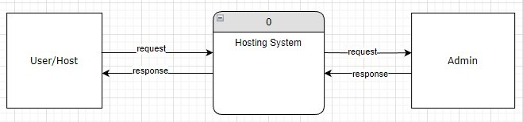

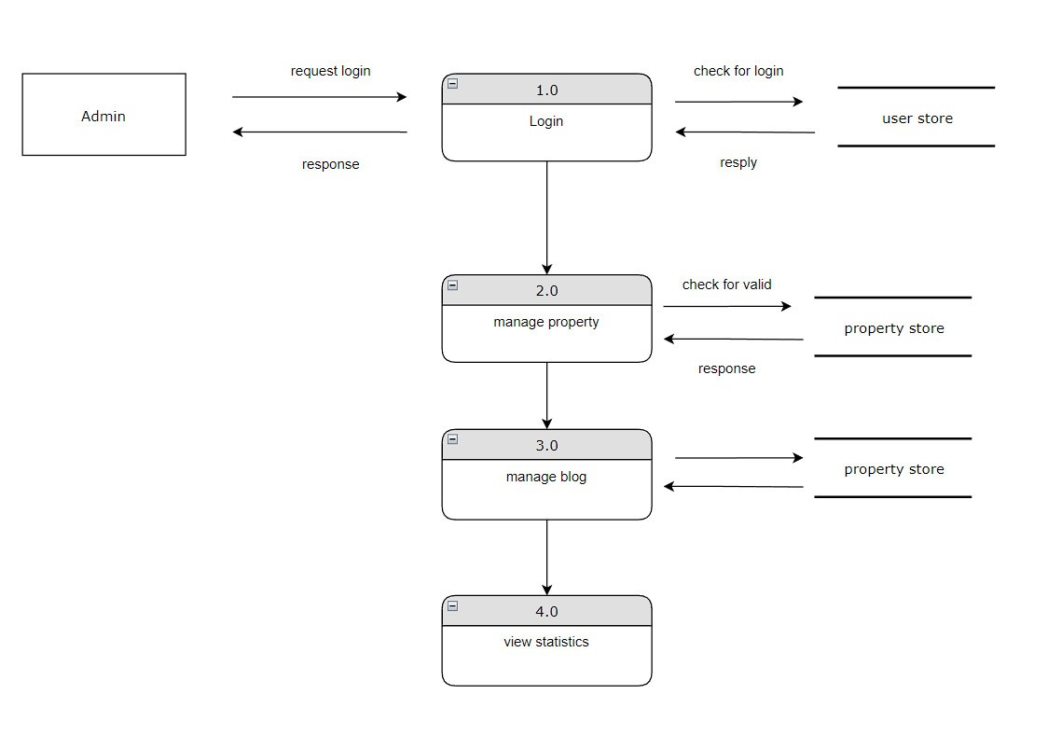**ADMINSIDE LEVEL 1**

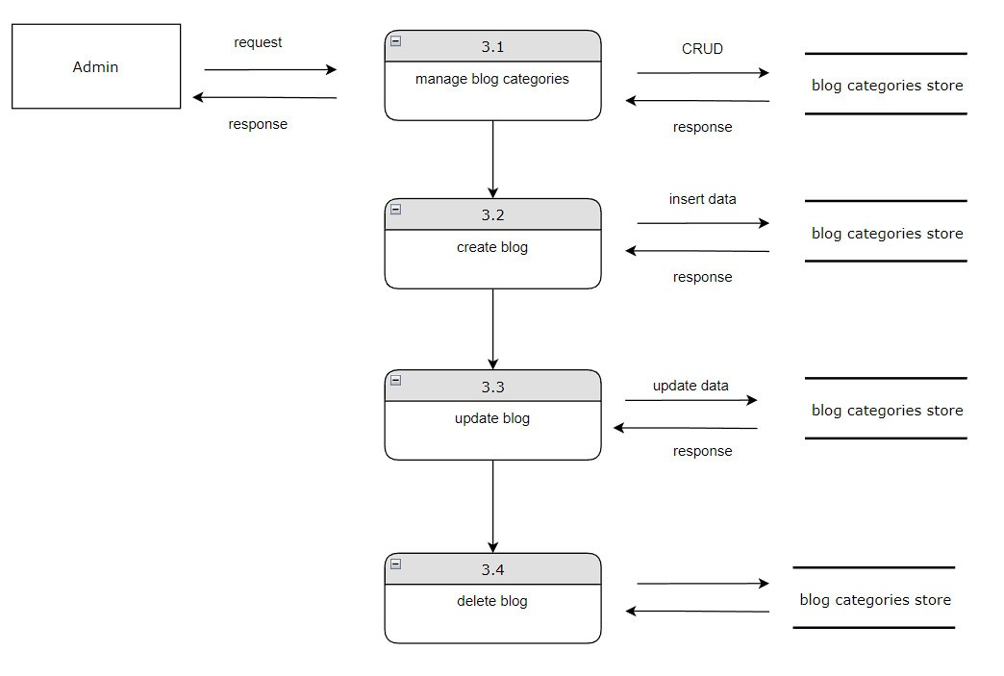

**HOST-SIDE LEVEL 1**

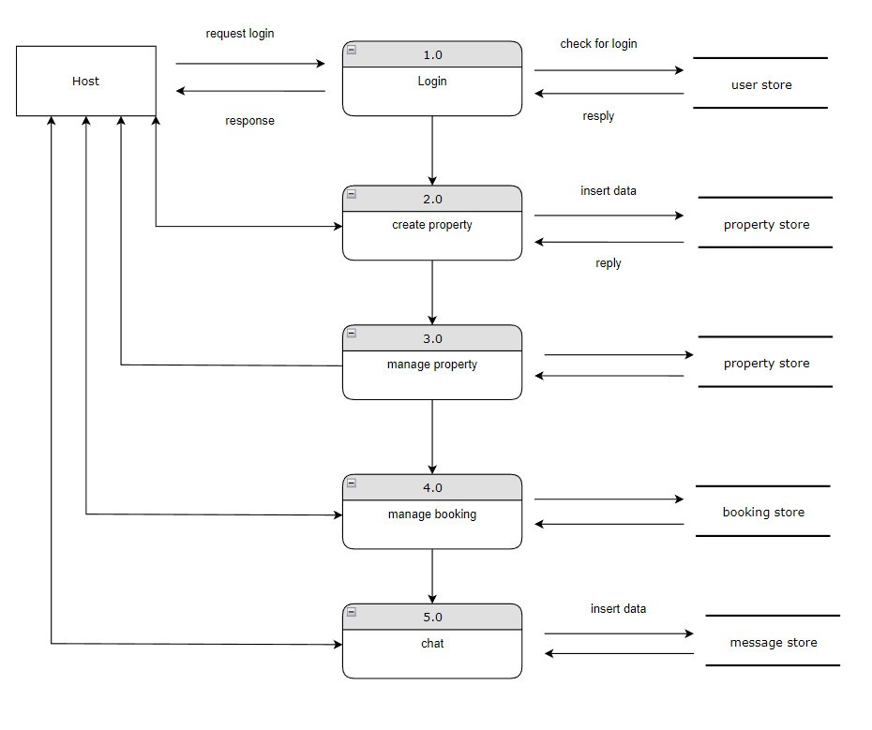

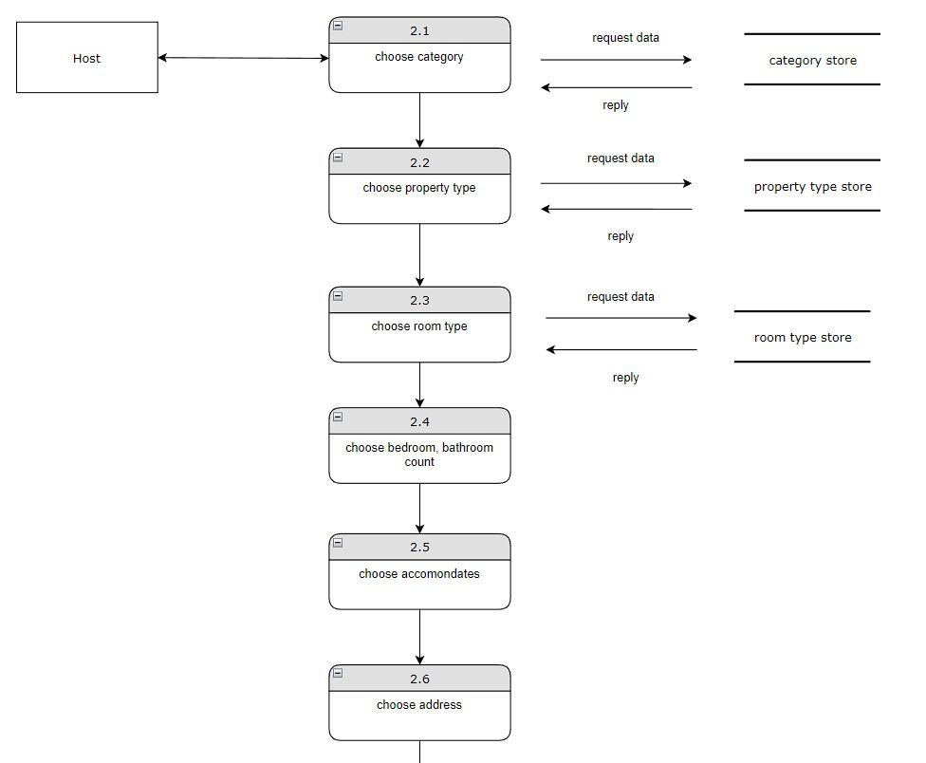

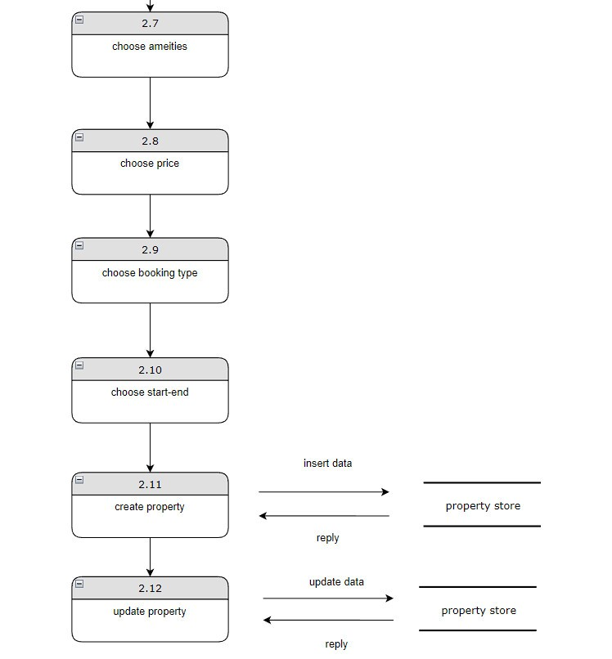

**USERSIDE LEVEL 1**

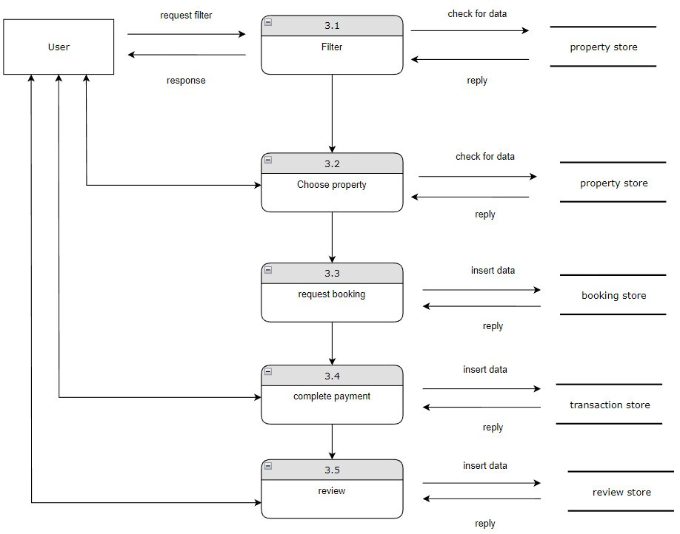

**USERSIDE LEVEL 2**

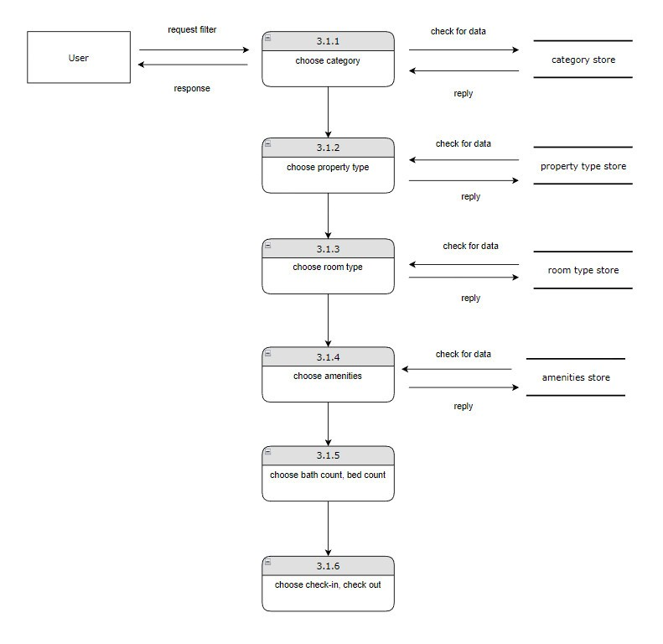

## ENTITY RELATIONSHIP DIAGRAM (ERD)

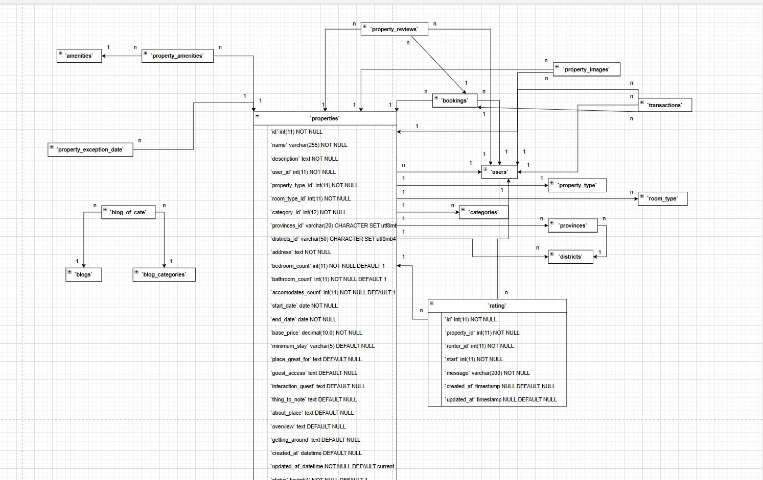**PHYSICAL ERD**

## TABLE DESIGN

## Table structure for table amenities

|  |  |  |  |
| --- | --- | --- | --- |
| **Column** | **Type** | **Null** | **Default** |
| **id** | int(11) | No |  |
| name | varchar(255) | No |  |
| icon_image | text | Yes | NULL |
| created_at | datetime | No | current_timestamp() |
| updated_at | datetime | Yes | NULL |
| status | tinyint(2) | Yes | 1 |
| type | varchar(50) | Yes | NULL |

## Table structure for table blogs

|  |  |  |  |
| --- | --- | --- | --- |
| **Column** | **Type** | **Null** | **Default** |
| ***id*** | int(12) | No |  |
| title | varchar(300) | No |  |
| content | text | No |  |
| image | varchar(255) | Yes | NULL |
| created_at | datetime | No | current_timestamp() |
| updated_at | datetime | Yes | NULL |

## Table structure for table blog_categories

|  |  |  |  |
| --- | --- | --- | --- |
| **Column** | **Type** | **Null** | **Default** |
| ***id*** | int(12) | No |  |
| name | varchar(200) | No |  |
| created_at | datetime | No | current_timestamp() |
| updated_at | datetime | Yes | NULL |

## Table structure for table blog_of_cate

|  |  |  |  |
| --- | --- | --- | --- |
| **Column** | **Type** | **Null** | **Default** |
| ***id*** | int(12) | No |  |
| id_blog | int(11) | No |  |
| id_blog_categories | int(11) | No |  |
| created_at | datetime | No | current_timestamp() |
| updated_at | datetime | Yes | NULL |

## Table structure for table bookings

|  |  |  |  |
| --- | --- | --- | --- |
| **Column** | **Type** | **Null** | **Default** |
| ***id*** | int(11) | No |  |
| property_id | int(11) | No |  |
| user_id | int(11) | No |  |
| check_in_date | date | No |  |
| check_out_date | date | No |  |
| price_per_day | decimal(10,0) | No |  |
| price_for_stay | decimal(10,0) | No |  |
| site_fees | decimal(10,0) | Yes | NULL |
| is_refund | tinyint(1) | Yes | NULL |
| cancle_date | datetime | Yes | NULL |
| refund_paid | decimal(10,0) | Yes | NULL |
| transaction_id | int(11) | Yes | NULL |
| booking_date | datetime | No |  |
| total_person | int(11) | No |  |
| created_at | datetime | No |  |
| updated_at | datetime | No |  |
| booking_status | varchar(50) | Yes | NULL |

## Table structure for table categories

|  |  |  |  |
| --- | --- | --- | --- |
| **Column** | **Type** | **Null** | **Default** |
| ***id*** | int(12) | No |  |
| name | varchar(255) | No |  |
| description | text | Yes | NULL |
| icon_image | varchar(255) | Yes | NULL |
| created_at | datetime | No | current_timestamp() |
| updated_at | datetime | Yes | NULL |
| status | tinyint(2) | Yes | 1 |

## Table structure for table districts

|  |  |  |  |
| --- | --- | --- | --- |
| **Column** | **Type** | **Null** | **Default** |
| ***code*** | varchar(50) | No |  |
| name | varchar(255) | No |  |
| name_en | varchar(255) | Yes | NULL |
| full_name | varchar(255) | Yes | NULL |
| full_name_en | varchar(255) | Yes | NULL |
| code_name | varchar(255) | Yes | NULL |
| province_code | varchar(20) | Yes | NULL |
| administrative_unit_id | int(11) | Yes | NULL |

## Table structure for table failed_jobs

|  |  |  |  |
| --- | --- | --- | --- |
| **Column** | **Type** | **Null** | **Default** |
| ***id*** | bigint(20) | No |  |
| **uuid** | varchar(255) | No |  |
| connection | text | No |  |
| queue | text | No |  |
| payload | longtext | No |  |
| exception | longtext | No |  |
| failed_at | timestamp | No | current_timestamp() |

## Table structure for table migrations

|  |  |  |  |
| --- | --- | --- | --- |
| **Column** | **Type** | **Null** | **Default** |
| ***id*** | int(10) | No |  |
| migration | varchar(255) | No |  |
| batch | int(11) | No |  |

## Table structure for table password_reset_tokens

|  |  |  |  |
| --- | --- | --- | --- |
| **Column** | **Type** | **Null** | **Default** |
| ***email*** | varchar(255) | No |  |
| token | varchar(255) | No |  |
| created_at | timestamp | Yes | NULL |

## Table structure for table personal_access_tokens

|  |  |  |  |
| --- | --- | --- | --- |
| **Column** | **Type** | **Null** | **Default** |
| ***id*** | bigint(20) | No |  |
| tokenable_type | varchar(255) | No |  |
| tokenable_id | bigint(20) | No |  |
| name | varchar(255) | No |  |
| **token** | varchar(64) | No |  |
| abilities | text | Yes | NULL |
| last_used_at | timestamp | Yes | NULL |
| expires_at | timestamp | Yes | NULL |
| created_at | timestamp | Yes | NULL |
| updated_at | timestamp | Yes | NULL |

## Table structure for table properties

|  |  |  |  |
| --- | --- | --- | --- |
| **Column** | **Type** | **Null** | **Default** |
| ***id*** | int(11) | No |  |
| name | varchar(255) | No |  |
| description | text | No |  |
| user_id | int(11) | No |  |
| property_type_id | int(11) | No |  |
| room_type_id | int(11) | No |  |
| category_id | int(12) | No |  |
| provinces_id | varchar(20) | No |  |
| districts_id | varchar(50) | No |  |
| address | text | No |  |
| bedroom_count | int(11) | No | 1 |
| bathroom_count | int(11) | No | 1 |
| accomodates_count | int(11) | No | 1 |
| start_date | date | No |  |
| end_date | date | No |  |
| base_price | decimal(10,0) | No |  |
| minimum_stay | varchar(5) | Yes | NULL |
| place_great_for | text | Yes | NULL |
| guest_access | text | Yes | NULL |
| interaction_guest | text | Yes | NULL |
| thing_to_note | text | Yes | NULL |
| about_place | text | Yes | NULL |
| overview | text | Yes | NULL |
| getting_around | text | Yes | NULL |
| created_at | datetime | Yes | NULL |
| updated_at | datetime | No | current_timestamp() |
| status | tinyint(4) | No | 1 |
| booking_type | varchar(50) | Yes | NULL |
| check_in_after | varchar(50) | Yes | NULL |
| check_out_before | varchar(50) | Yes | NULL |
| maximum_stay | int(11) | Yes | NULL |
| video | varchar(255) | Yes | NULL |
| property_status | tinyint(1) | No |  |
| acception_status | varchar(20) | Yes | waiting |
| admin_message | varchar(255) | Yes | NULL |

## Table structure for table property_amenities

|  |  |  |  |
| --- | --- | --- | --- |
| **Column** | **Type** | **Null** | **Default** |
| ***id*** | int(11) | No |  |
| property_id | int(11) | No |  |
| amenity_id | int(11) | No |  |
| created_at | datetime | No | current_timestamp() |
| updated_at | datetime | Yes | NULL |
| status | int(11) | No | 1 |

## Table structure for table property_exception_date

|  |  |  |  |
| --- | --- | --- | --- |
| **Column** | **Type** | **Null** | **Default** |
| ***id*** | int(11) | No |  |
| property_id | int(11) | No |  |
| start_date | date | Yes | NULL |
| end_date | date | Yes | NULL |
| created_at | datetime | Yes | NULL |
| updated_at | datetime | Yes | NULL |

## Table structure for table property_images

|  |  |  |  |
| --- | --- | --- | --- |
| **Column** | **Type** | **Null** | **Default** |
| ***id*** | int(11) | No |  |
| property_id | int(11) | No |  |
| add_by_user | int(11) | No |  |
| image | text | No |  |
| created_at | datetime | No | current_timestamp() |
| updated_at | datetime | Yes | NULL |
| status | int(11) | No | 1 |

## Table structure for table property_reviews

|  |  |  |  |
| --- | --- | --- | --- |
| **Column** | **Type** | **Null** | **Default** |
| ***id*** | int(11) | No |  |
| property_id | int(11) | No |  |
| review_by_user | int(11) | No |  |
| booking_id | int(11) | No |  |
| comment | text | No |  |
| rating | varchar(10) | No |  |
| created_at | datetime | No | current_timestamp() |
| updated_at | datetime | Yes | NULL |
| status | int(11) | No | 1 |

## Table structure for table property_type

|  |  |  |  |
| --- | --- | --- | --- |
| **Column** | **Type** | **Null** | **Default** |
| ***id*** | int(11) | No |  |
| name | varchar(255) | No |  |
| icon_image | varchar(255) | Yes | NULL |
| created_at | datetime | No | current_timestamp() |
| updated_at | datetime | No | current_timestamp() |
| status | tinyint(2) | No | 1 |

## Table structure for table provinces

|  |  |  |  |
| --- | --- | --- | --- |
| **Column** | **Type** | **Null** | **Default** |
| ***code*** | varchar(20) | No |  |
| name | varchar(255) | No |  |
| name_en | varchar(255) | Yes | NULL |
| full_name | varchar(255) | No |  |
| full_name_en | varchar(255) | Yes | NULL |
| code_name | varchar(255) | Yes | NULL |
| administrative_unit_id | int(11) | Yes | NULL |
| administrative_region_id | int(11) | Yes | NULL |

## Table structure for table rating

|  |  |  |  |
| --- | --- | --- | --- |
| **Column** | **Type** | **Null** | **Default** |
| ***id*** | int(11) | No |  |
| property_id | int(11) | No |  |
| renter_id | int(11) | No |  |
| start | int(11) | No |  |
| message | varchar(200) | No |  |
| created_at | timestamp | Yes | NULL |
| updated_at | timestamp | Yes | NULL |

## Table structure for table room_type

|  |  |  |  |
| --- | --- | --- | --- |
| **Column** | **Type** | **Null** | **Default** |
| ***id*** | int(11) | No |  |
| name | varchar(255) | No |  |
| icon_image | text | Yes | NULL |
| created_at | datetime | No | current_timestamp() |
| updated_at | datetime | Yes | NULL |
| status | tinyint(2) | No | 1 |

## Table structure for table tp_messages

|  |  |  |  |
| --- | --- | --- | --- |
| **Column** | **Type** | **Null** | **Default** |
| ***id*** | int(11) | No |  |
| from_email | varchar(255) | No |  |
| to_email | varchar(255) | No |  |
| body | varchar(250) | No |  |
| created_at | timestamp | Yes | NULL |
| updated_at | timestamp | Yes | NULL |

## Table structure for table transactions

|  |  |  |  |
| --- | --- | --- | --- |
| **Column** | **Type** | **Null** | **Default** |
| ***id*** | int(11) | No |  |
| payment_id | varchar(100) | No |  |
| property_id | int(11) | No |  |
| reciever_id | int(11) | No |  |
| payee_id | int(11) | No |  |
| booking_id | int(11) | No |  |
| site_fees | decimal(10,0) | No |  |
| host_fee | decimal(10,0) | No |  |
| amount | decimal(10,0) | No |  |
| transfer_on | datetime | No | current_timestamp() |
| created_at | datetime | Yes | NULL |
| updated_at | datetime | Yes | NULL |
| status | int(11) | No | 1 |

## Table structure for table users

|  |  |  |  |
| --- | --- | --- | --- |
| **Column** | **Type** | **Null** | **Default** |
| ***id*** | int(11) | No |  |
| first_name | varchar(255) | No |  |
| last_name | varchar(255) | No |  |
| **email** | varchar(255) | No |  |
| password | text | No |  |
| user_type | tinyint(2) | Yes | 1 |
| date_of_birth | date | No |  |
| about | text | Yes | NULL |
| image | varchar(255) | Yes | NULL |
| address | text | Yes | NULL |
| phonenumber | varchar(20) | Yes | NULL |
| gender | varchar(10) | Yes | NULL |
| email_verify_at | date | Yes | NULL |
| created_at | datetime | No | current_timestamp() |
| updated_at | datetime | No |  |
| status | tinyint(2) | No | 1 |

## TASK SHEET REVIEW 2

|  |  |  |  |  |  |  |  |
| --- | --- | --- | --- | --- | --- | --- | --- |
| **Project: Airhouse** | | **Project Name** | **Activity Plan Prepared By** | **Date of Preparation of Activity Plan:** | | | |
| **Sr./No.** | **Task** | Actual Start Date | Actual Days | Team member name | Status |
| **1** | **Use Case** | **Airhouse** | Tân | 20-Dec-23 | 3 | Mai | Completed |
| **2** | **Data Flow Diagram (DFD)** | 20-Dec-23 | 3 | Tân | Completed |
| **3** | **Entity Relationship Diagram (ERD)** | 20-Dec-23 | 3 | Nhân | Completed |
| **4** | **Table Design** | 20-Dec-23 | 3 | Mai | Completed |
| Date: 30 December 2023 | | | | | | | |

|  |  |
| --- | --- |
| **Signature of Instructor:**  Ms. Le Mong Thuy | **Signature of Team Leader:**  Lương Xuân Phát |

# 

# REVIEW 3

## SITE MAP

**HOME SITE MAP**

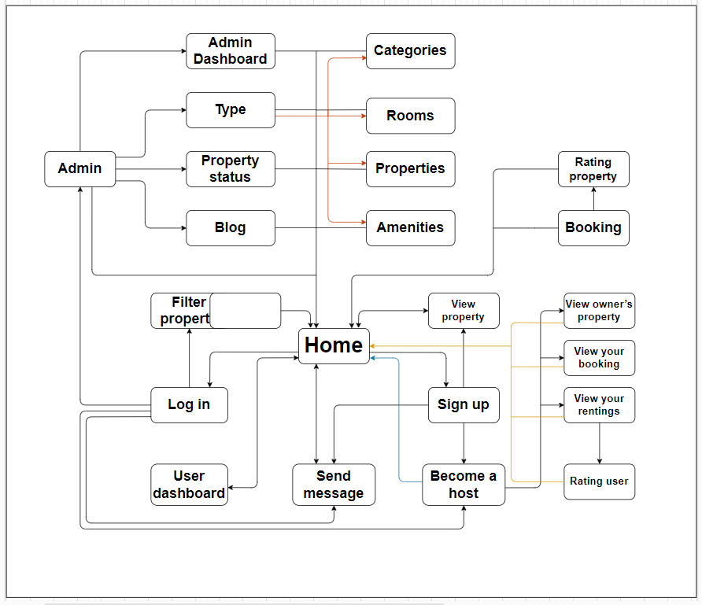

## AIRHOUSE WIREFRAME

1. **HOMEPAGE**

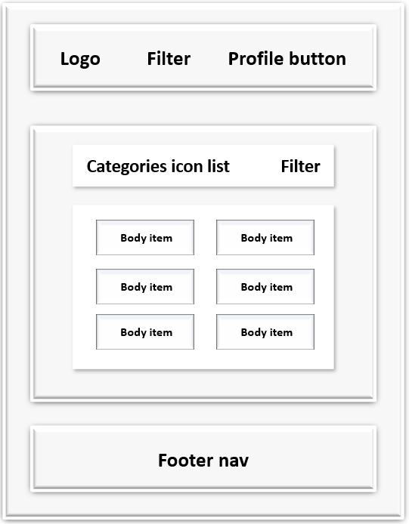

**2. Filter form**

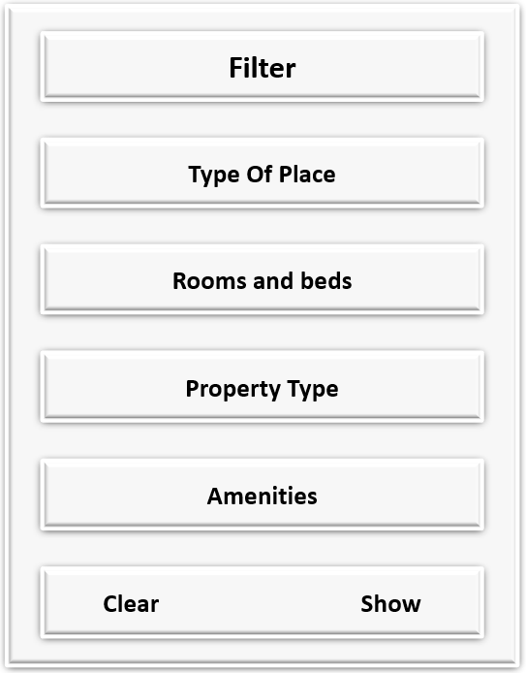

**3. Become a host page**

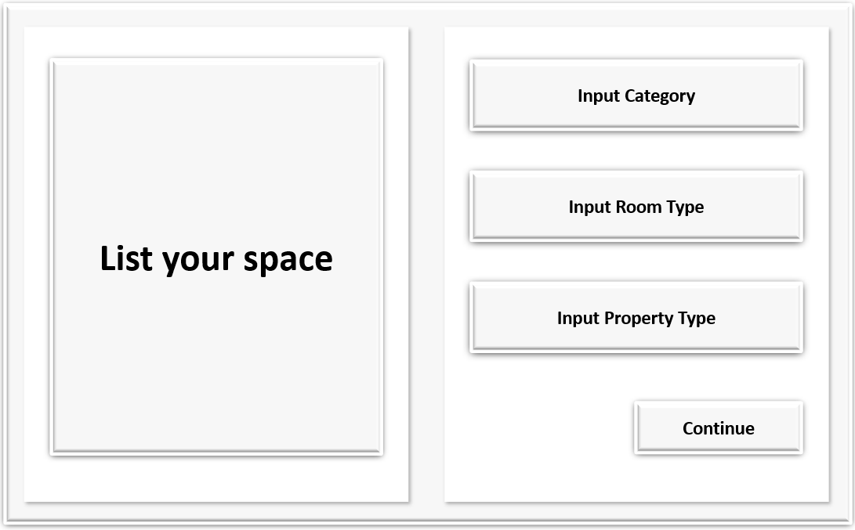

**4. Become a host basic page**

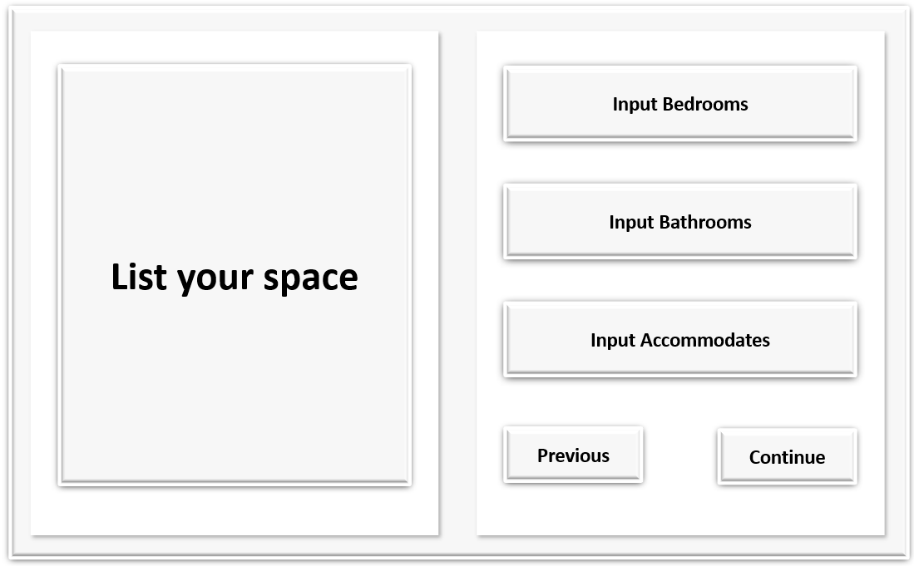

**5. Become a host page description**

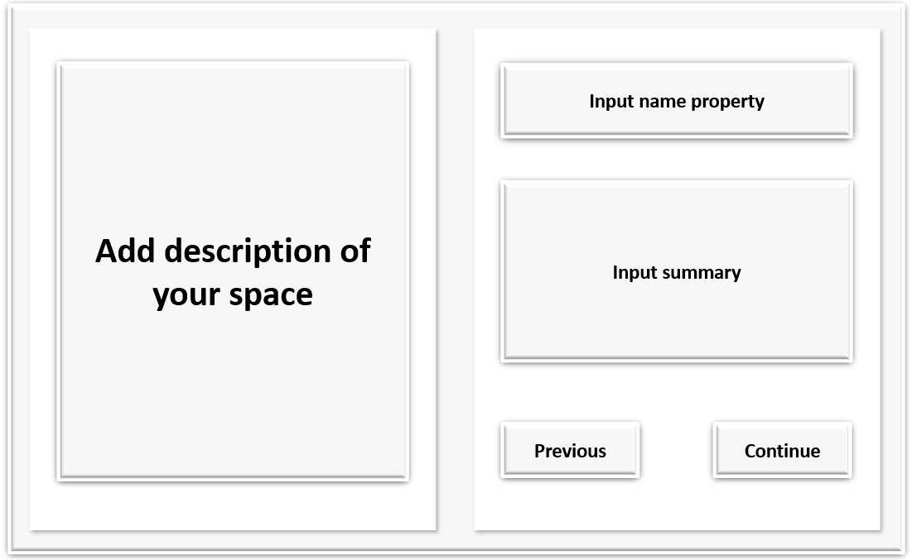

**6. Become a host detail**

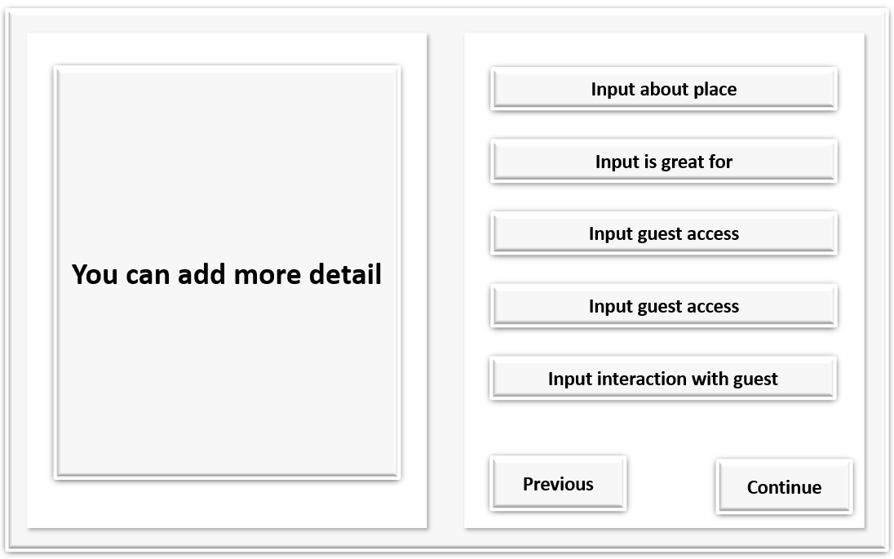

**7. Become a host Locations**

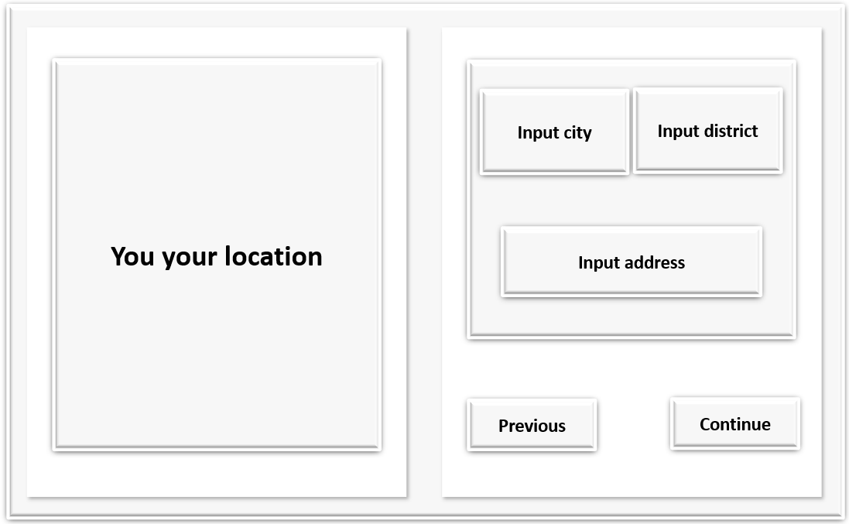

**8. Become a host Amenities**

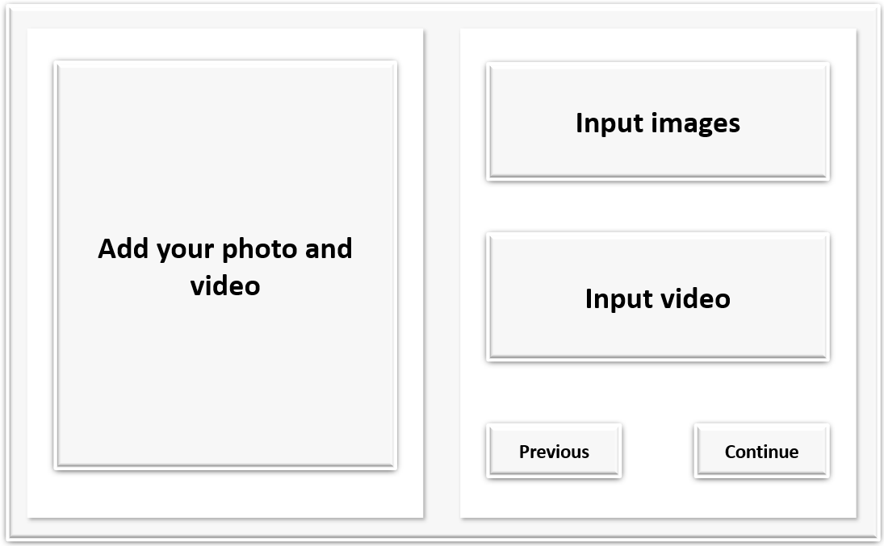

**9. Be come a host Photo**

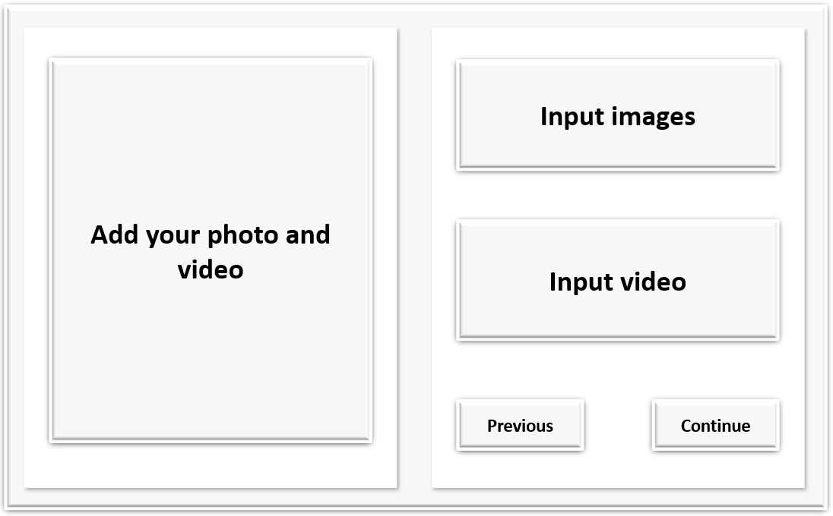

**10. Become a host pricing**

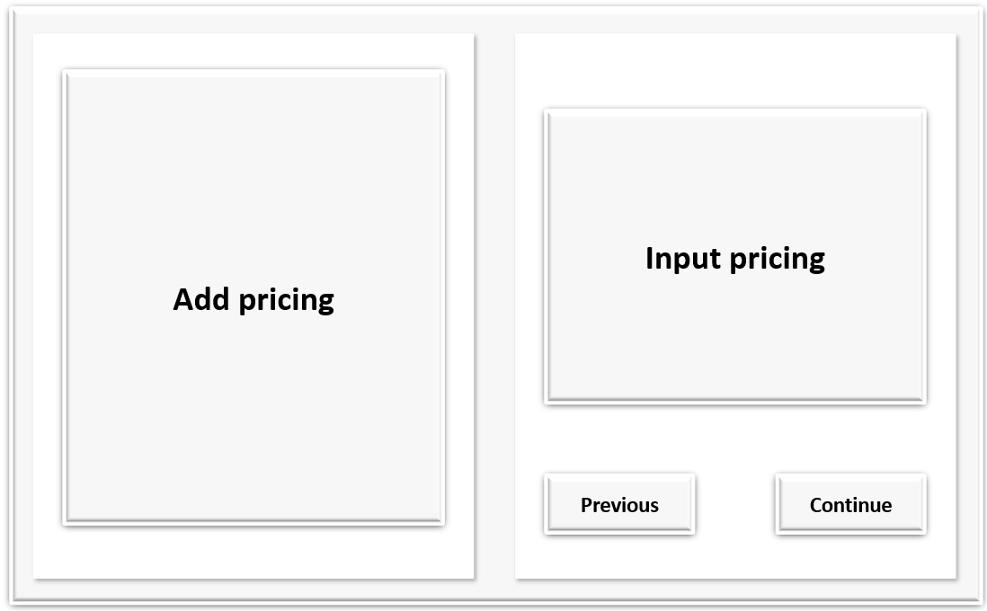

**11. Become a host Booking**

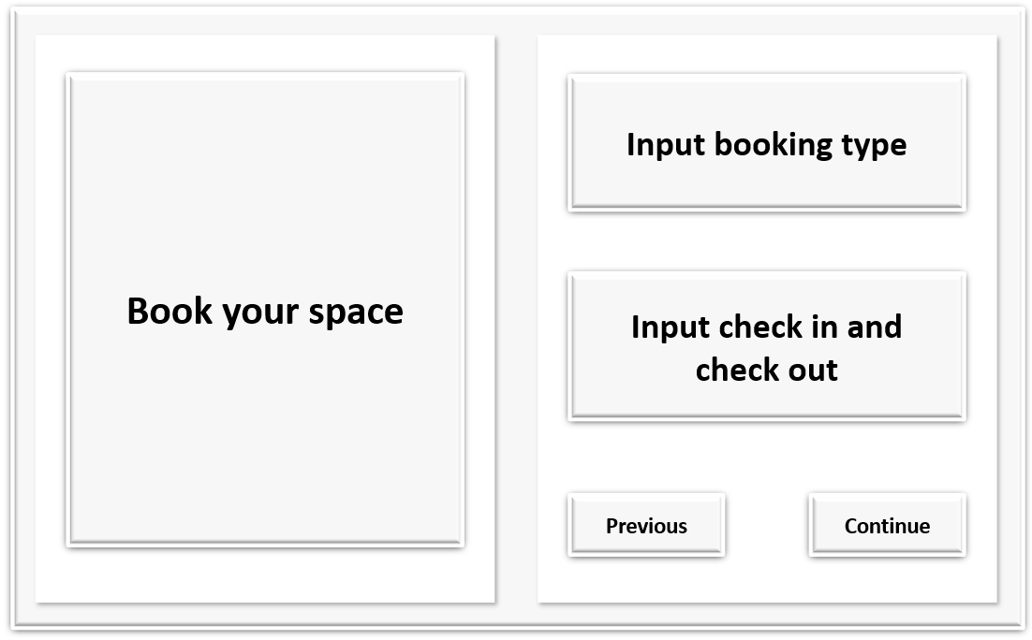

**12. Become a host Calendar**

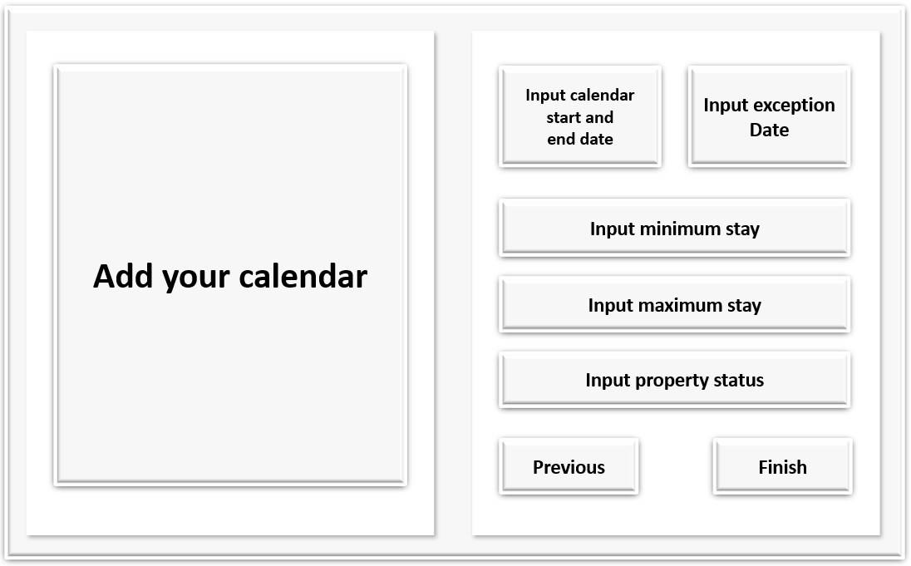

**13. Profile detail**

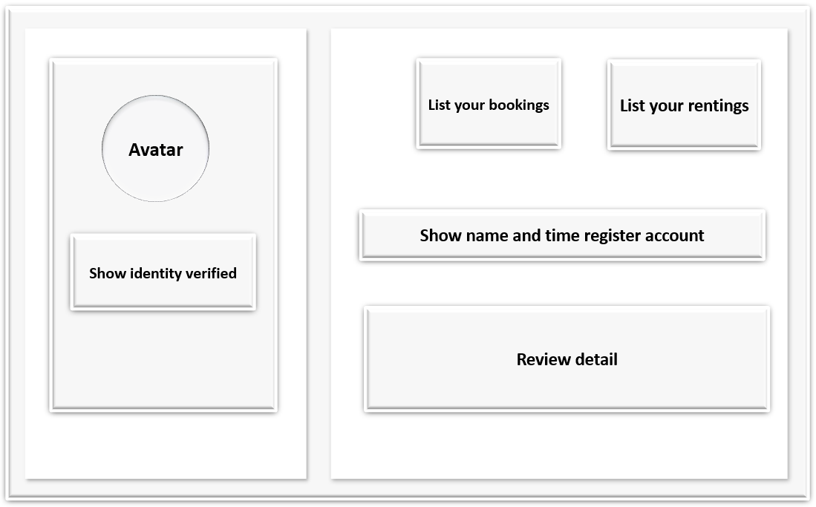

**14. Update profile detail**

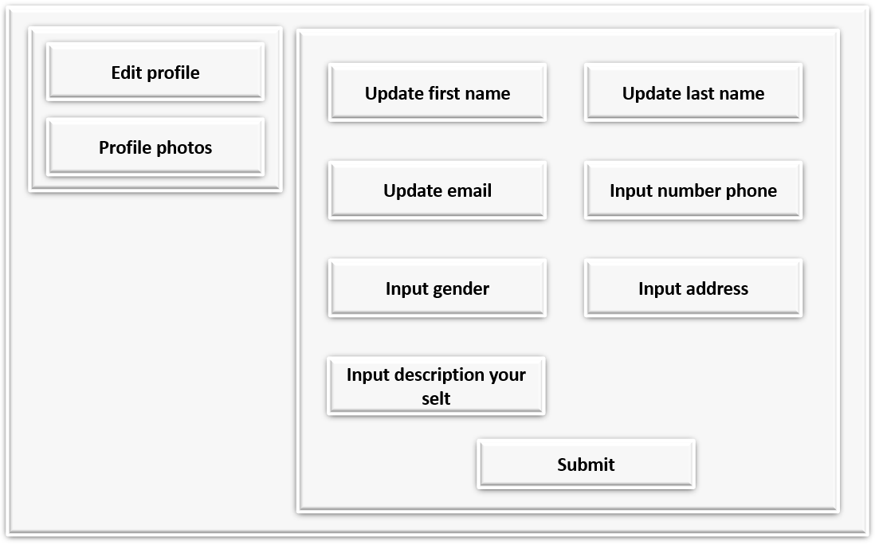

**15. My listing**

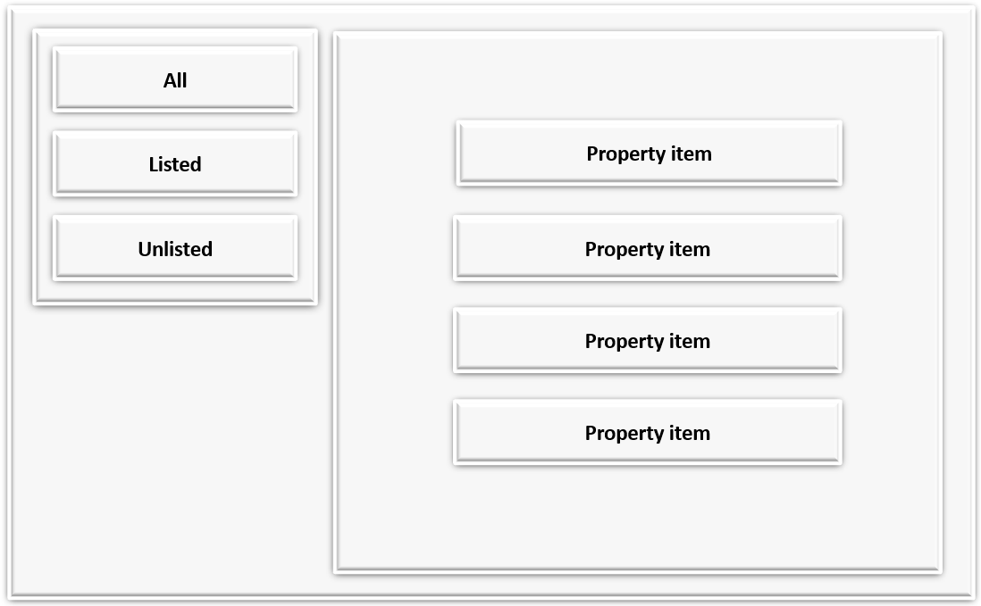

**16. My booking list**

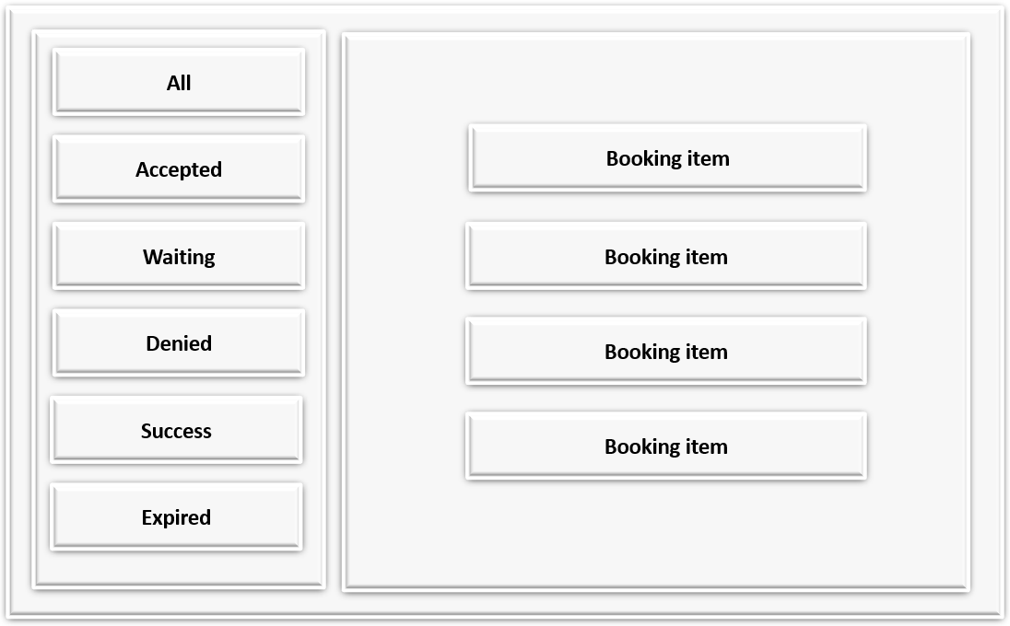

**17. My renting**

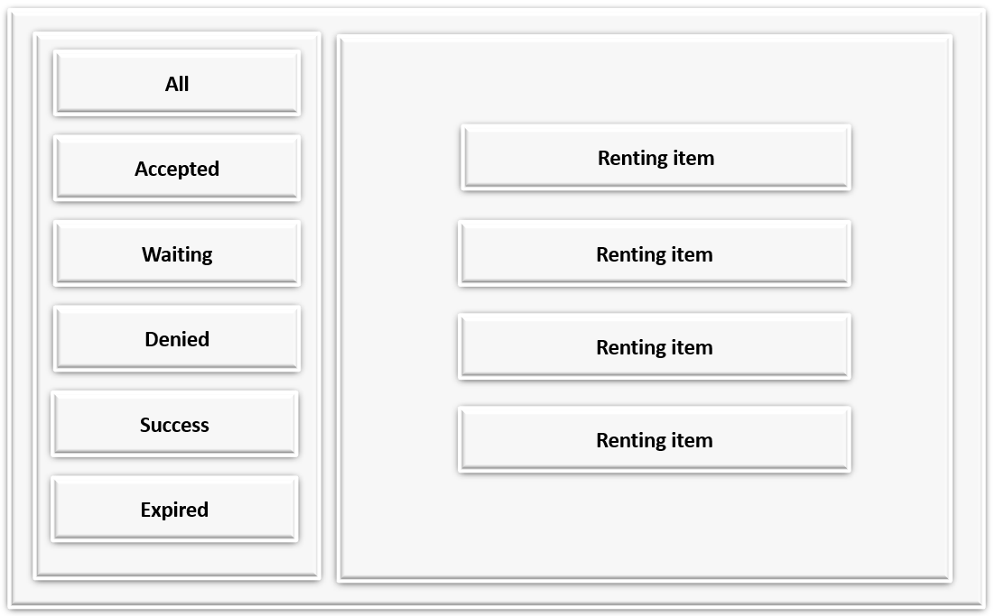

**18. Message**

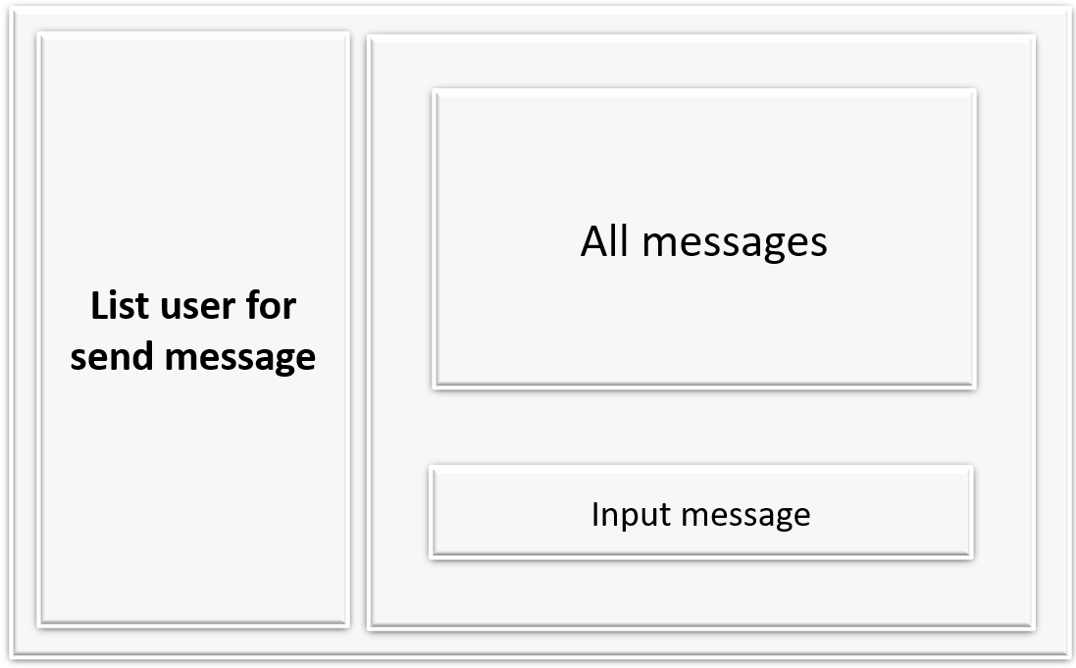

**19. Property information**

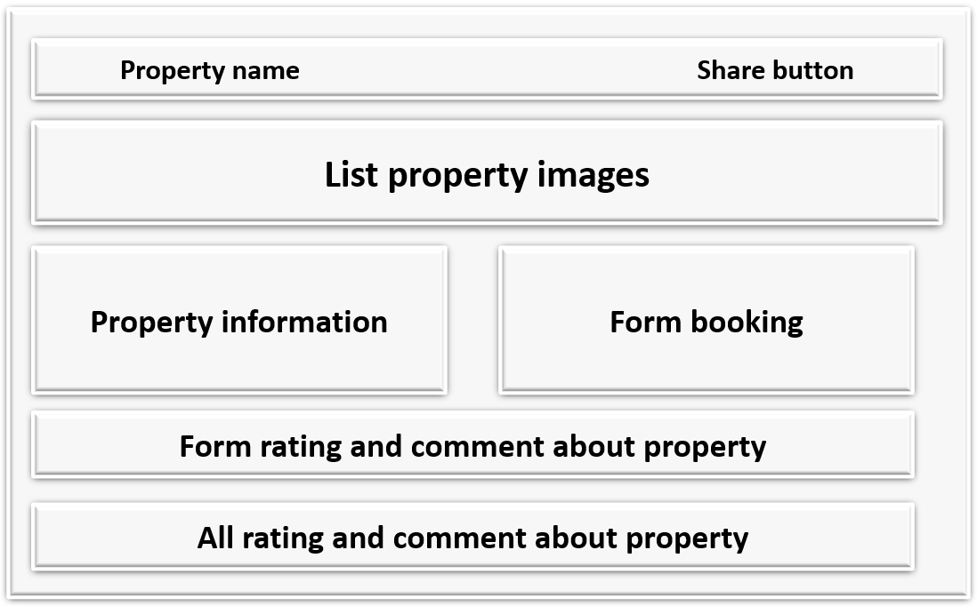

**20. Payment**

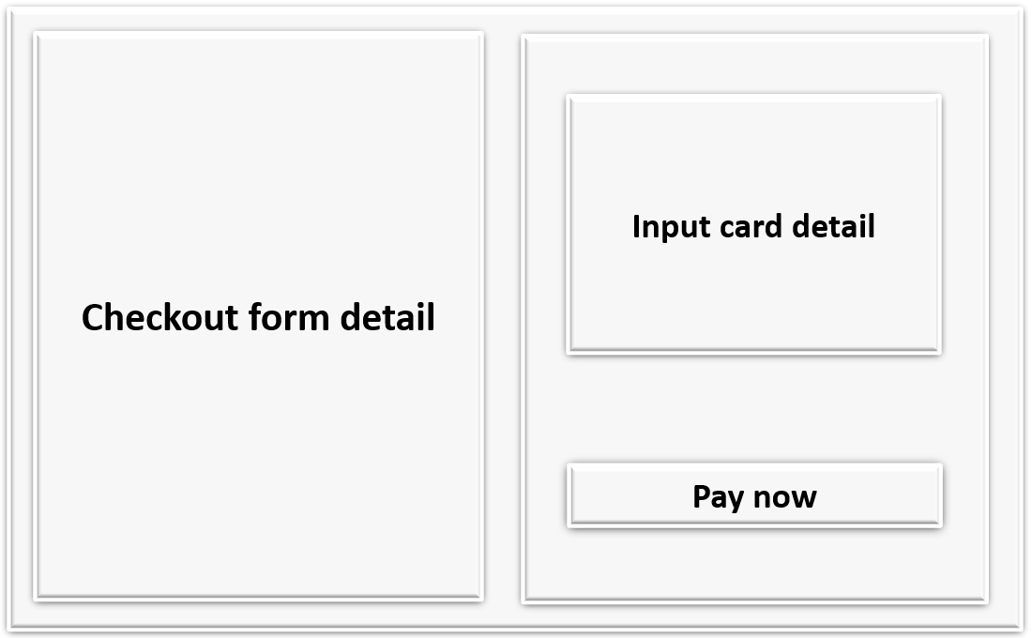

**21. Admin page**

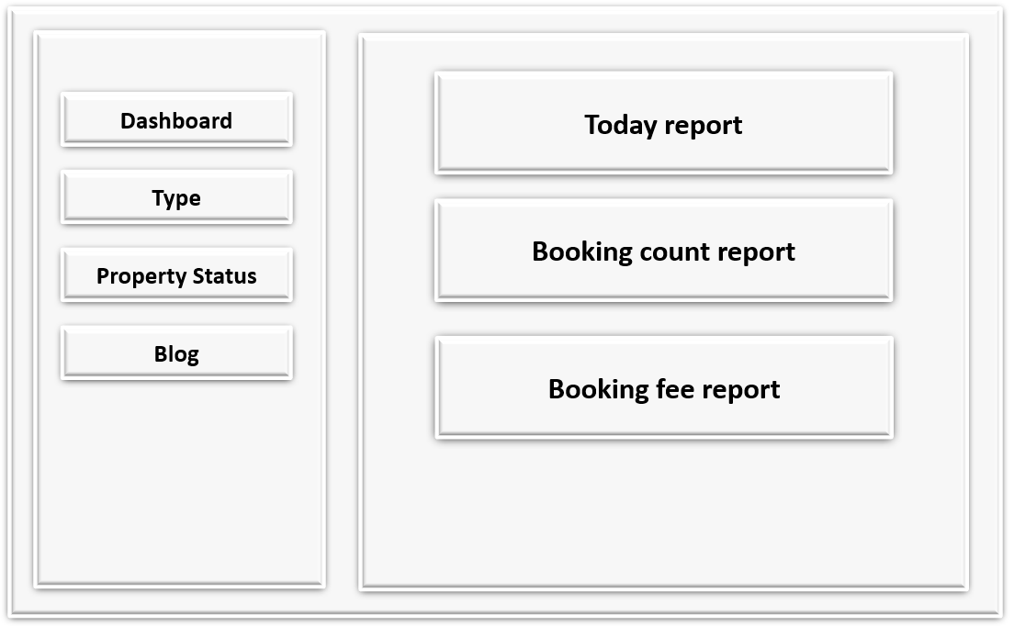

**22. Type form**

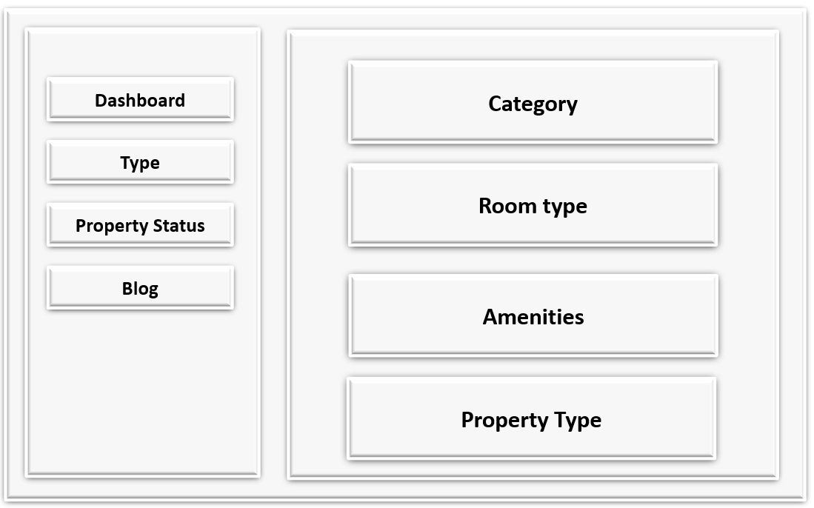

**23. Property status**

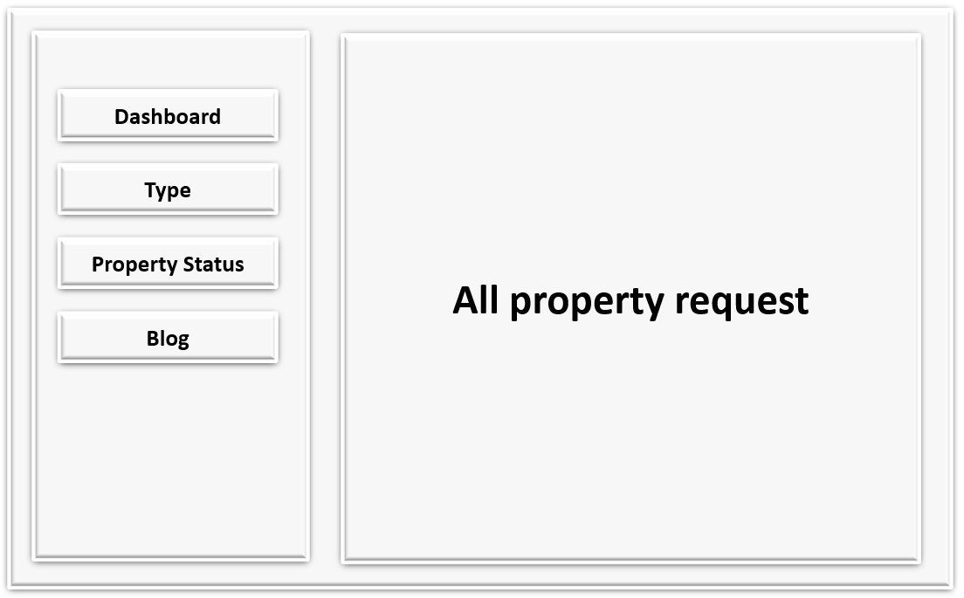

**24. Blog**

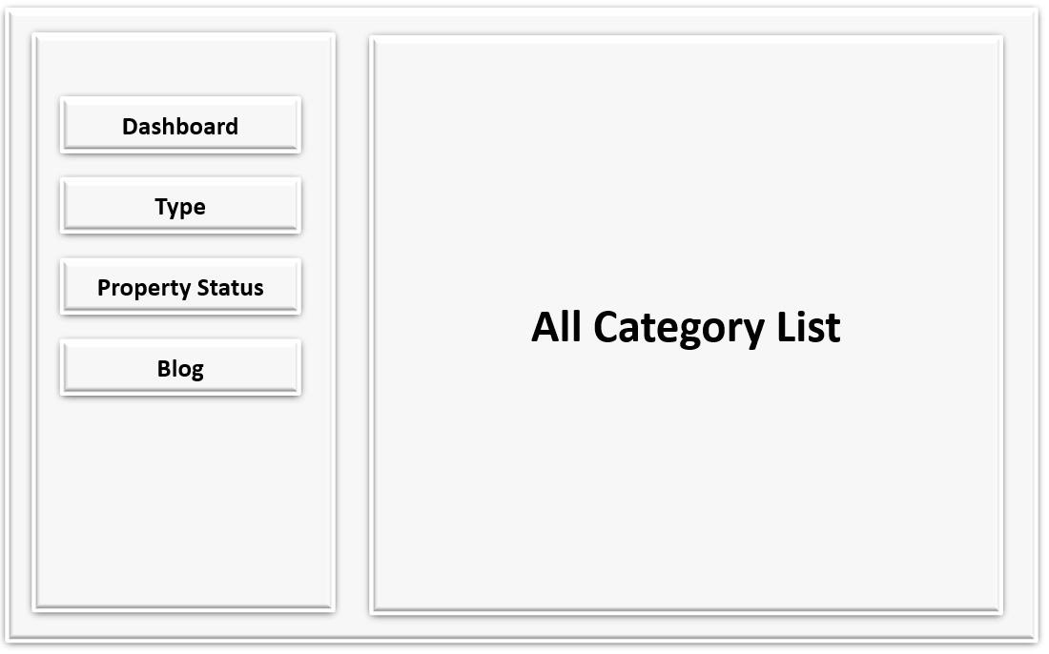

## AIRHOUSE SCREENSHOT

**HOME PAGE**

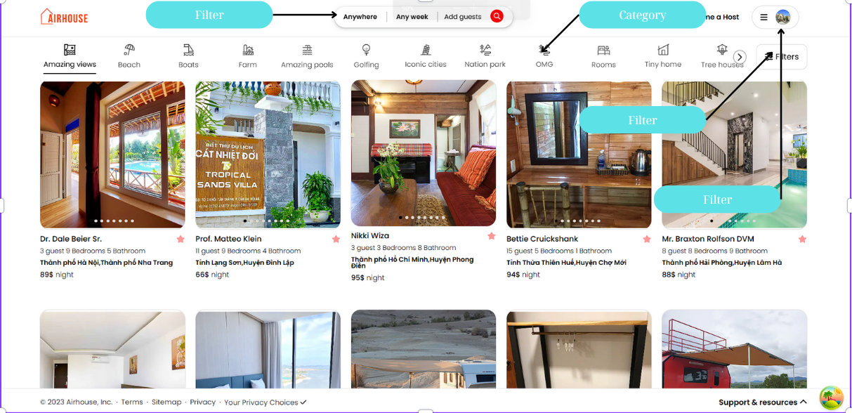

**AMENITIES TYPE PAGE**

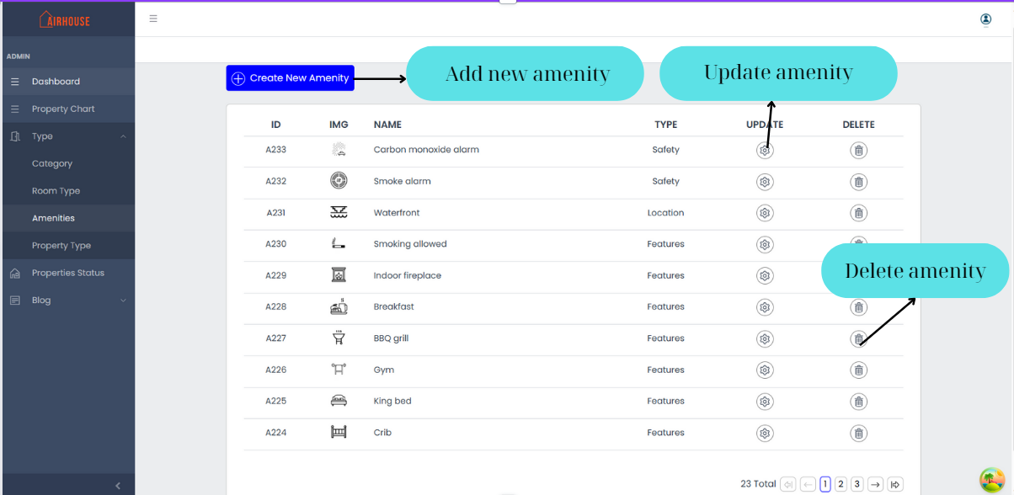

**PROPERTY TYPE PAGE**

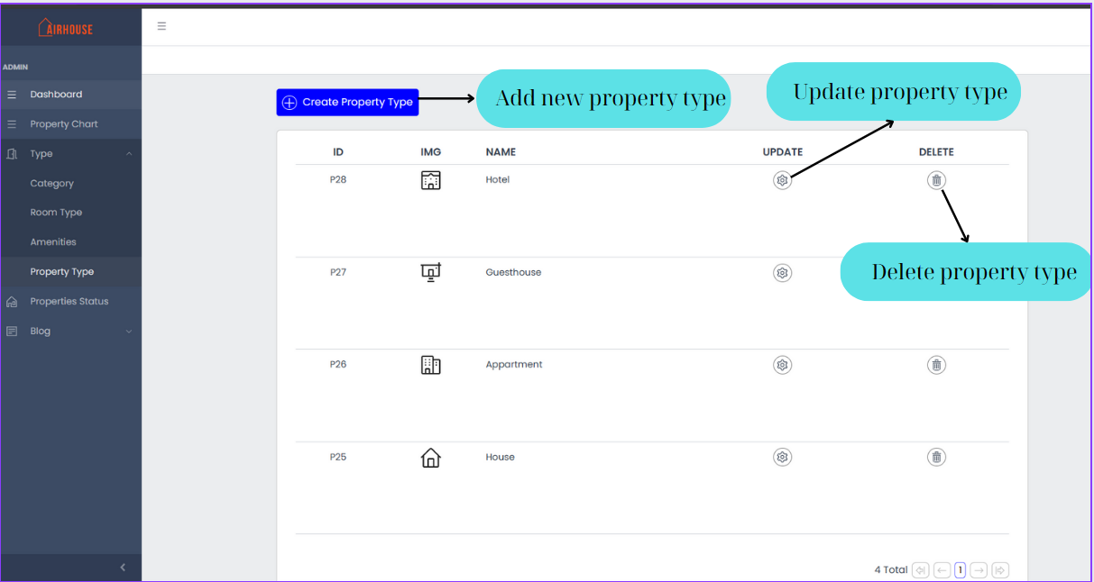

**REGISTER PAGE**

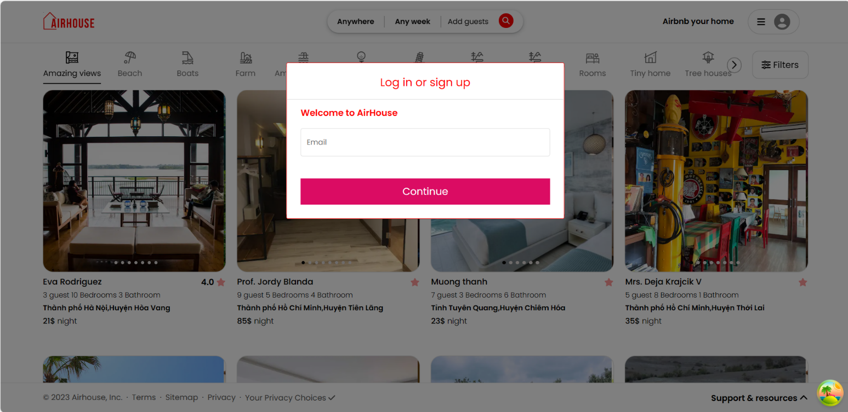

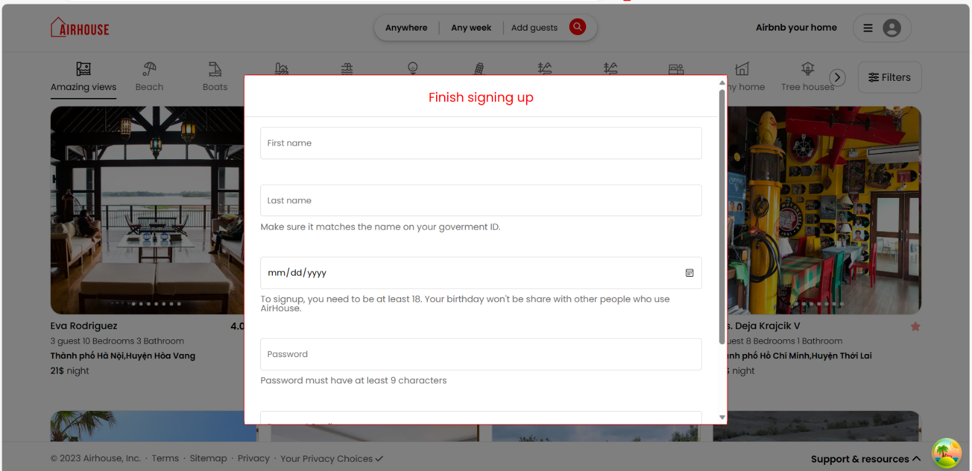

**LOGIN PAGE**

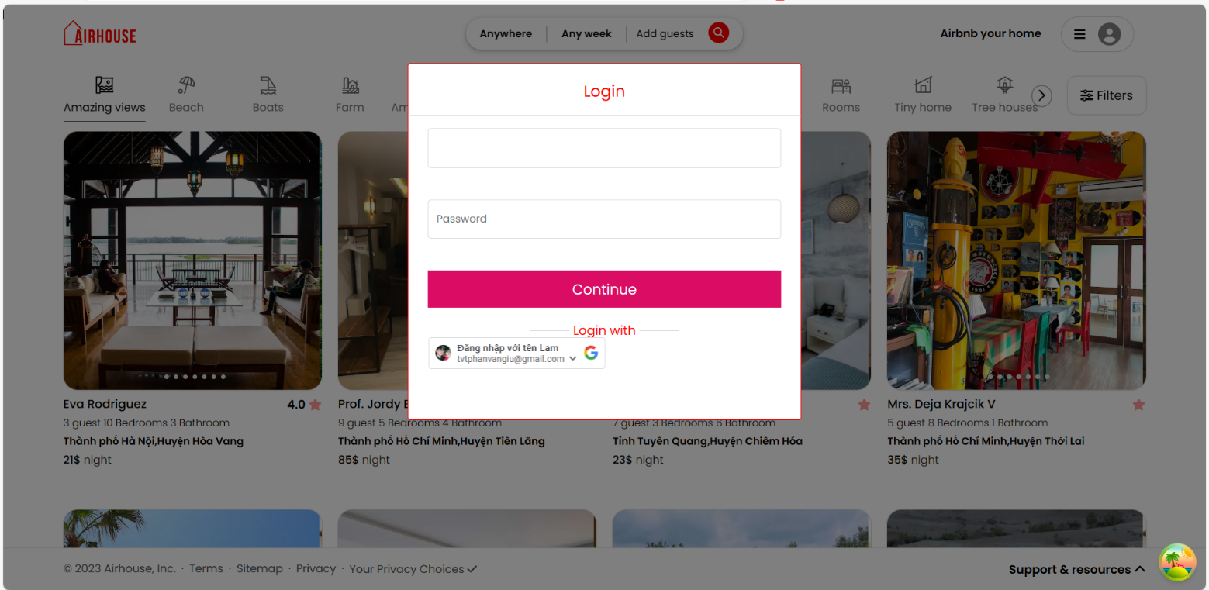

**INFORMATION PROPERTY PAGE**

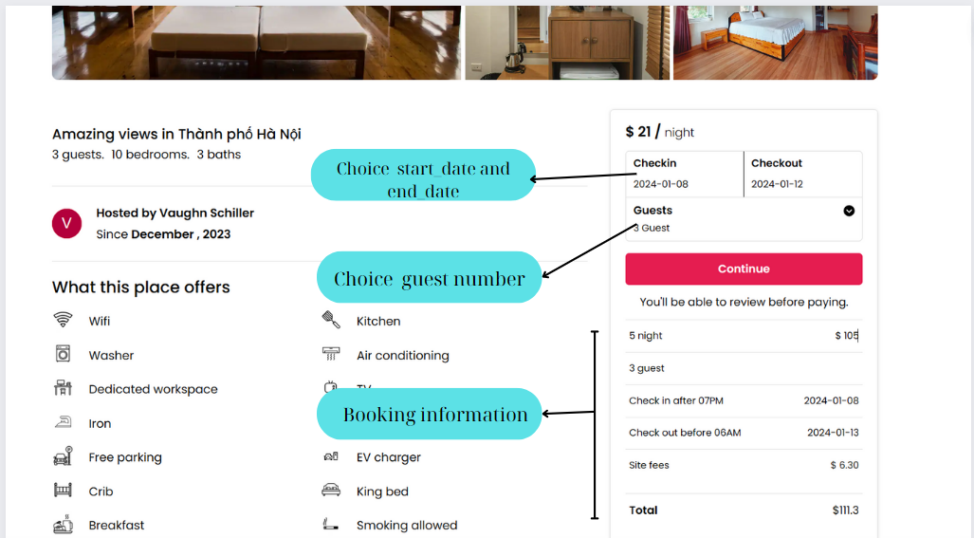

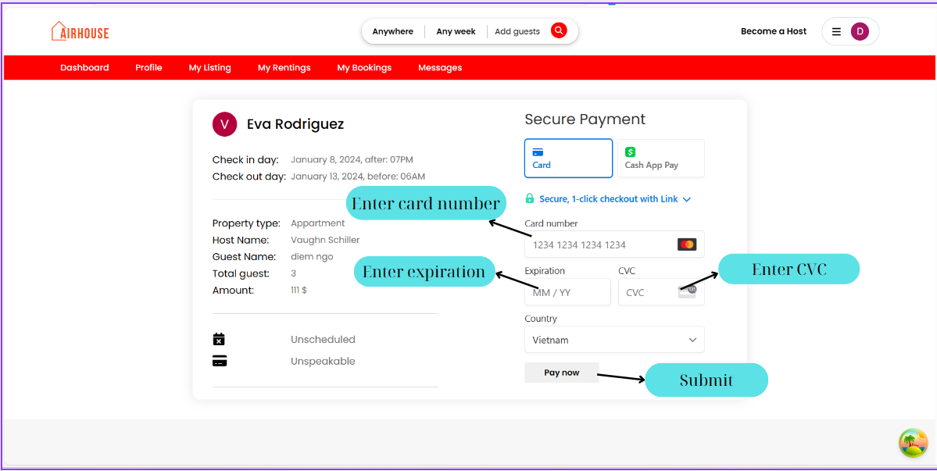

**RATING**

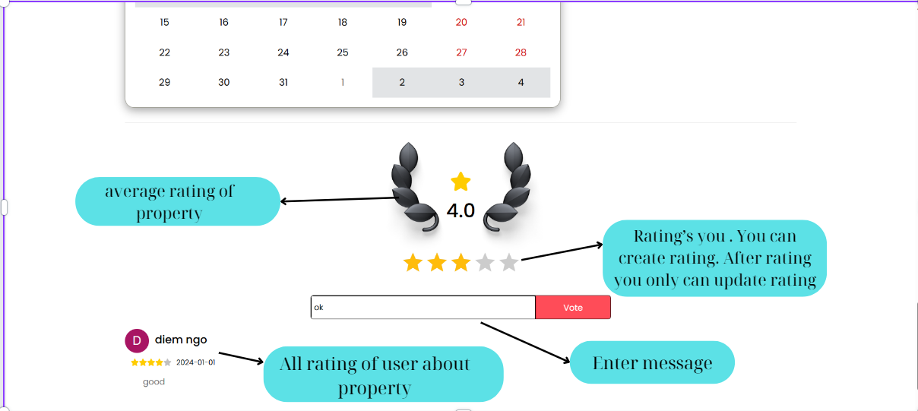

**PROPFILE DETAIL PAGE**

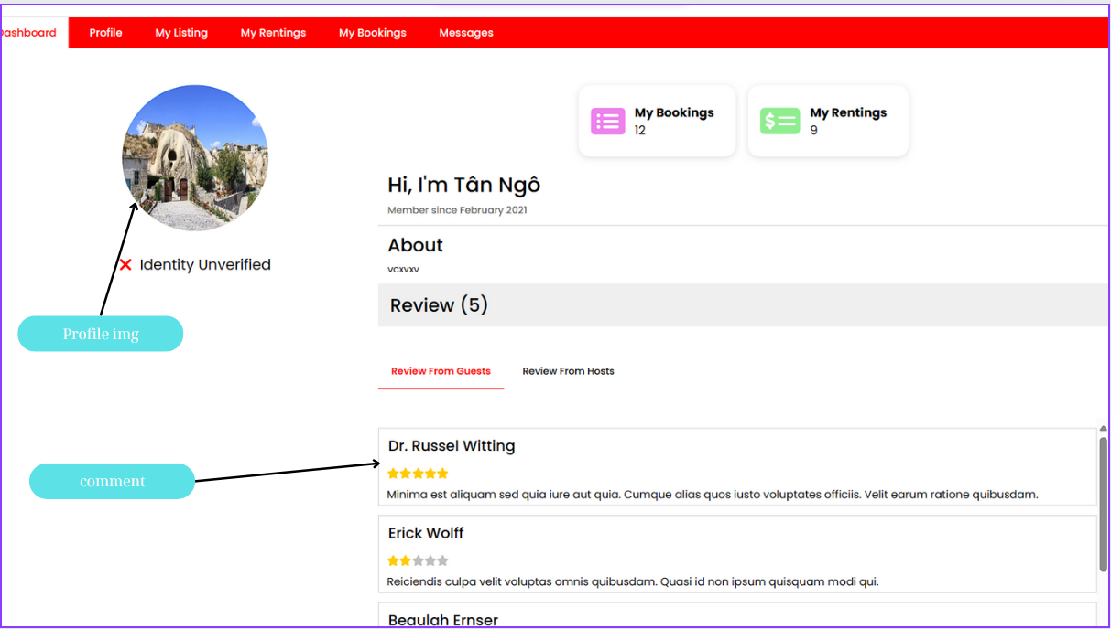

**UPADTE PROFILE PAGE**

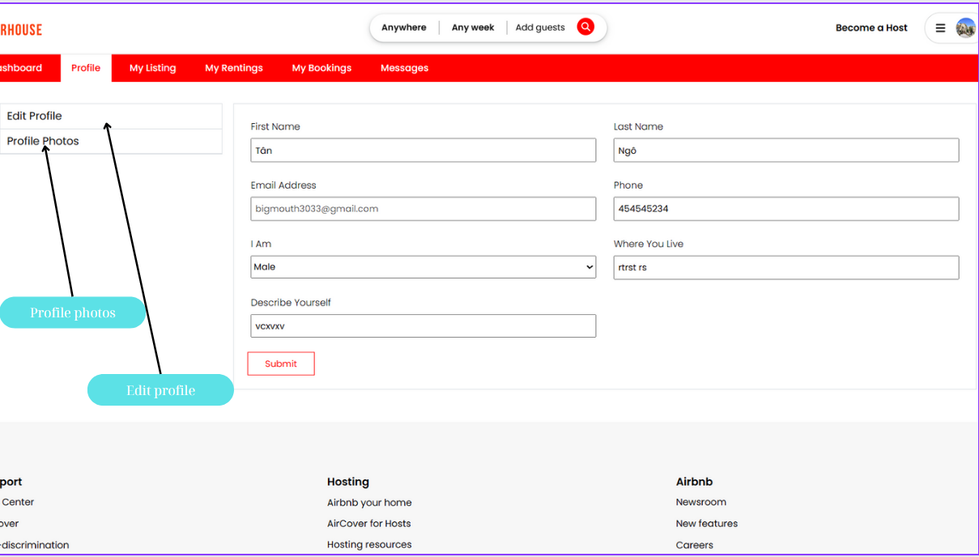

**MY LISTING PAGE**

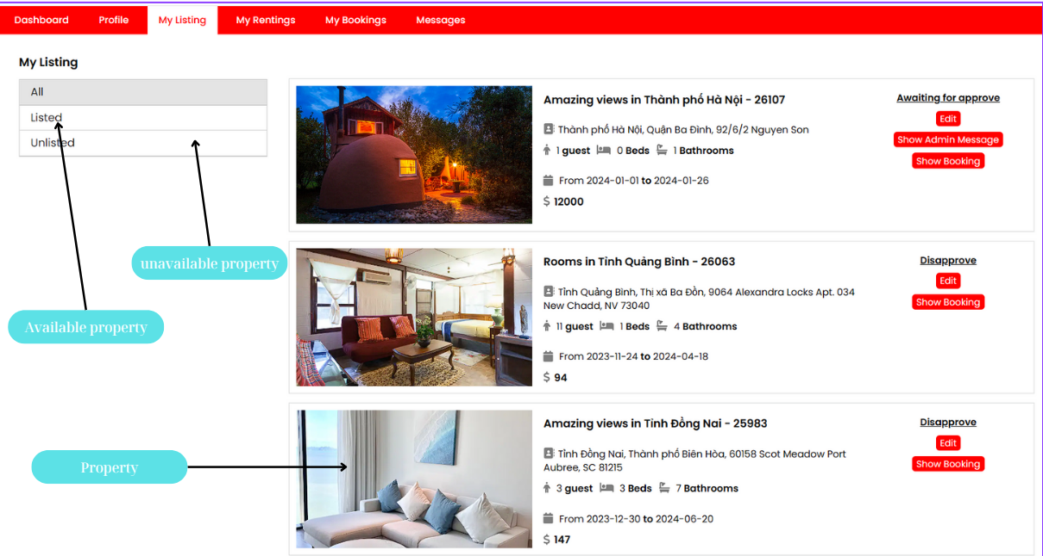

**MY BOOKING PAGE**

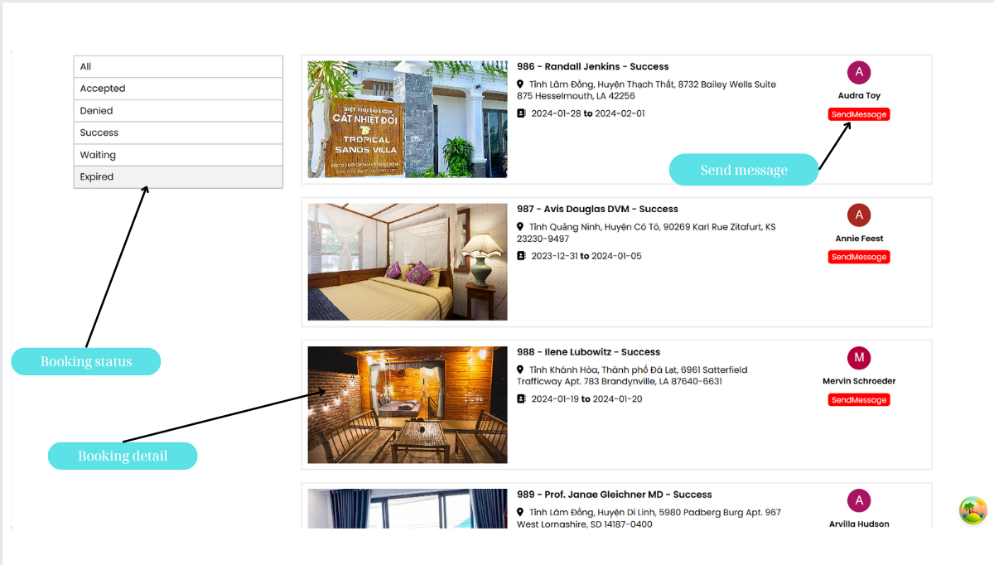

**MY RENGTING PAGE**

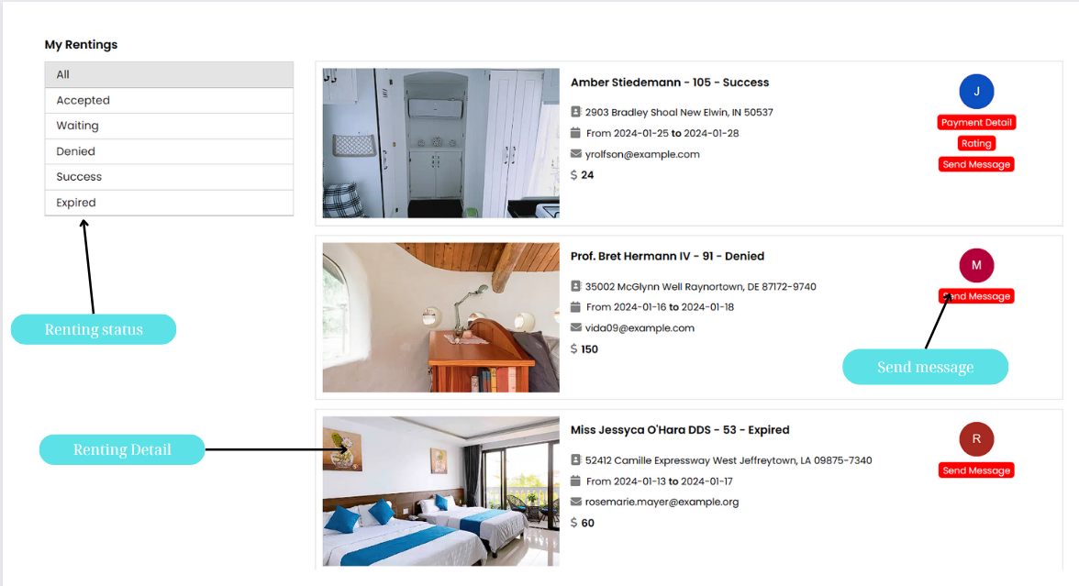

**CHAT PAGE**

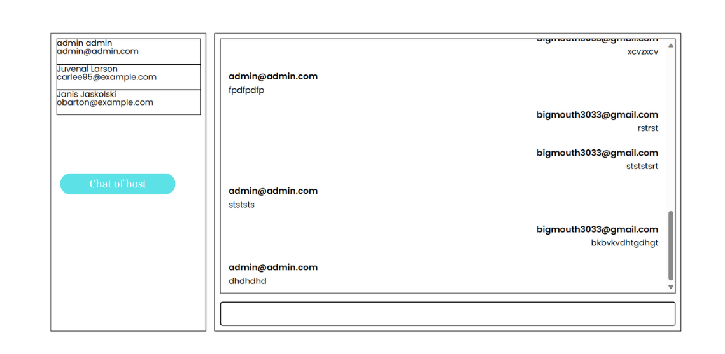

**ADMIN DASHBOARD**

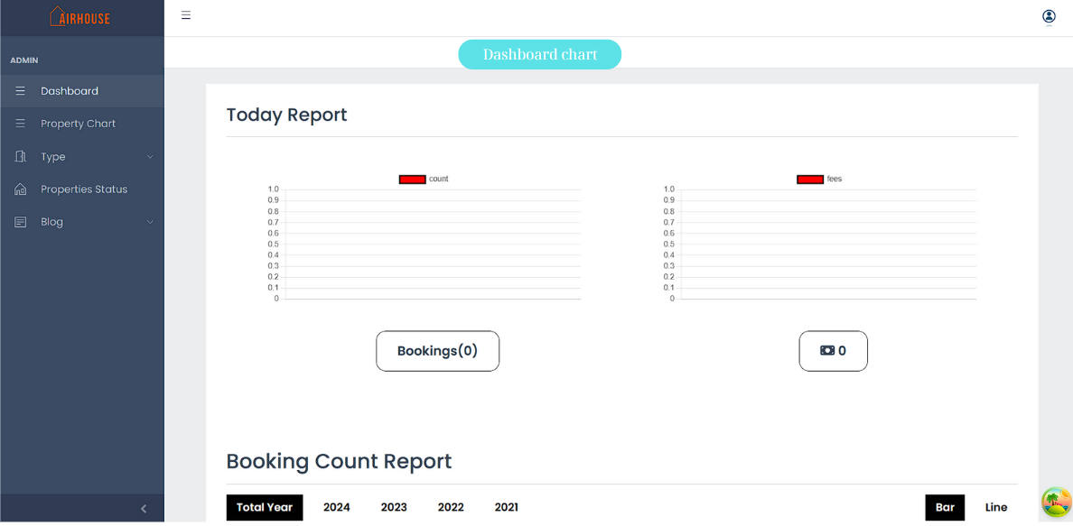

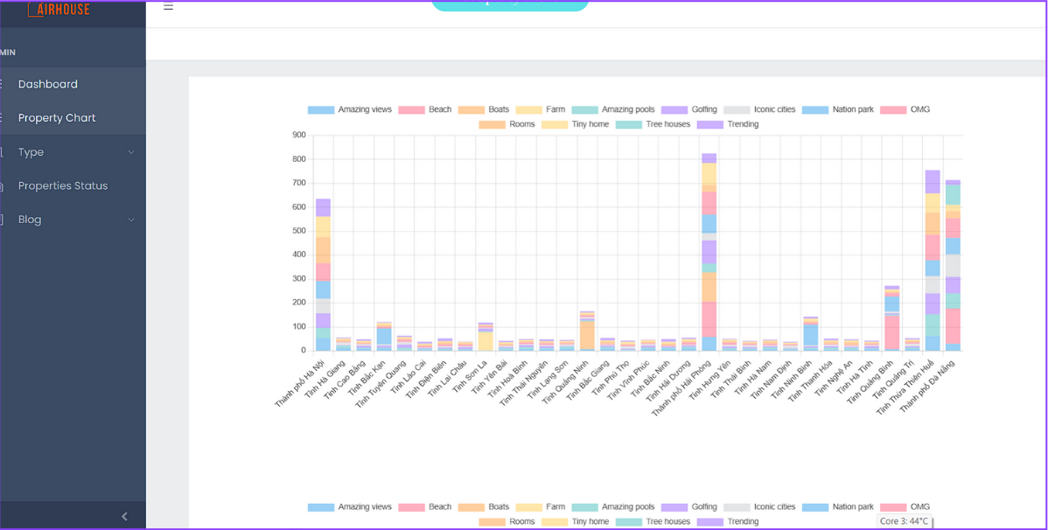

**BLOG LIST PAGE**

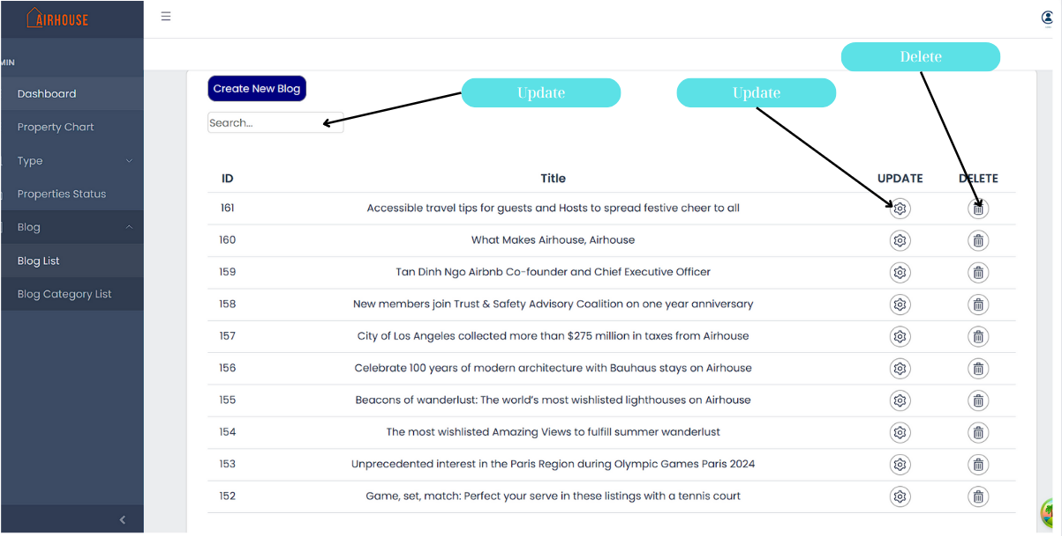

**BLOG CATETOGY PAGE**

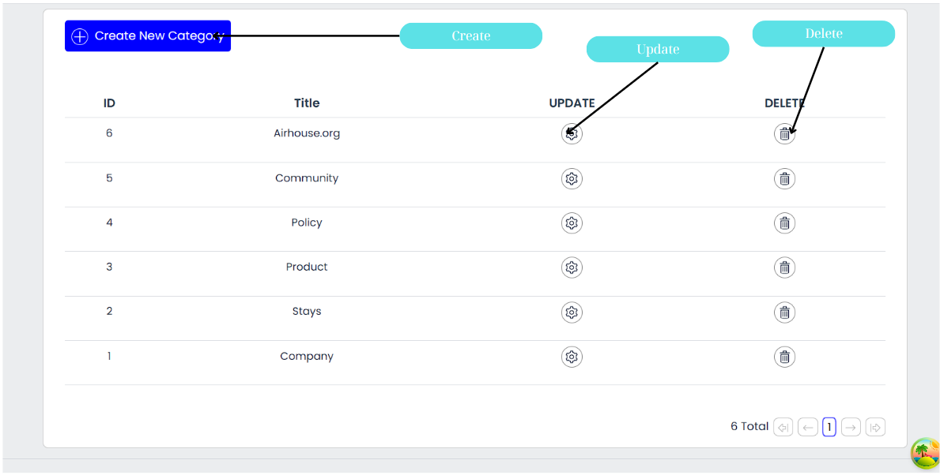

**PROPERTY STATUS PAGE**

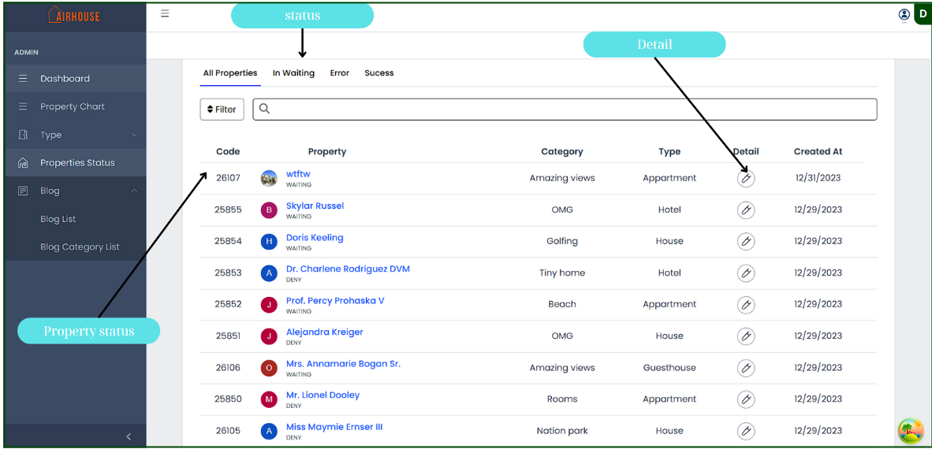

**HOST A PROPERY PAGE**

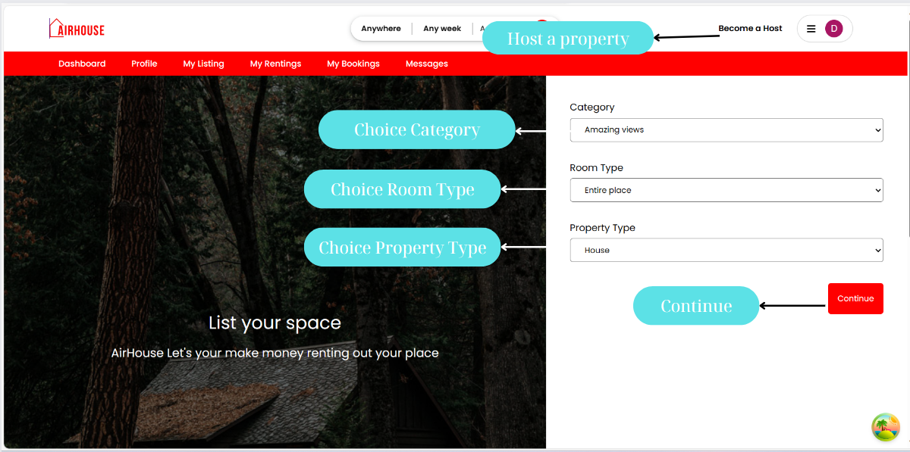

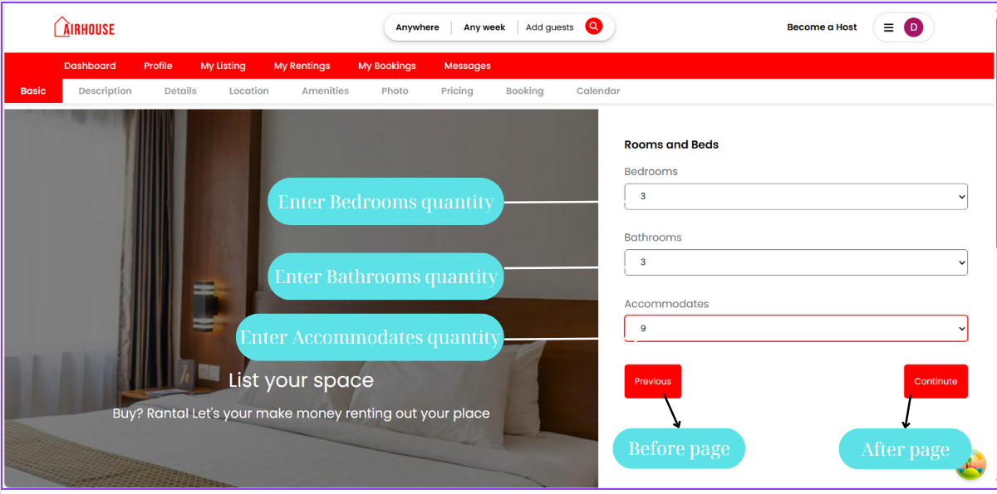

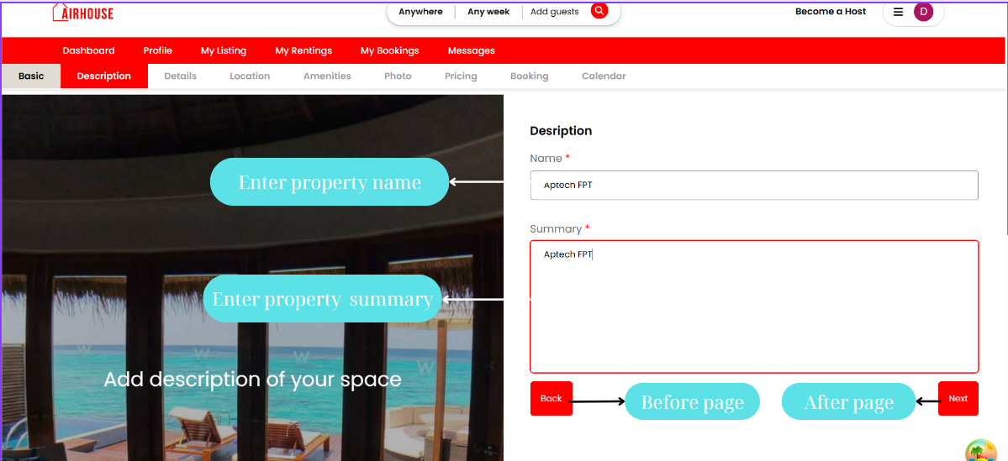

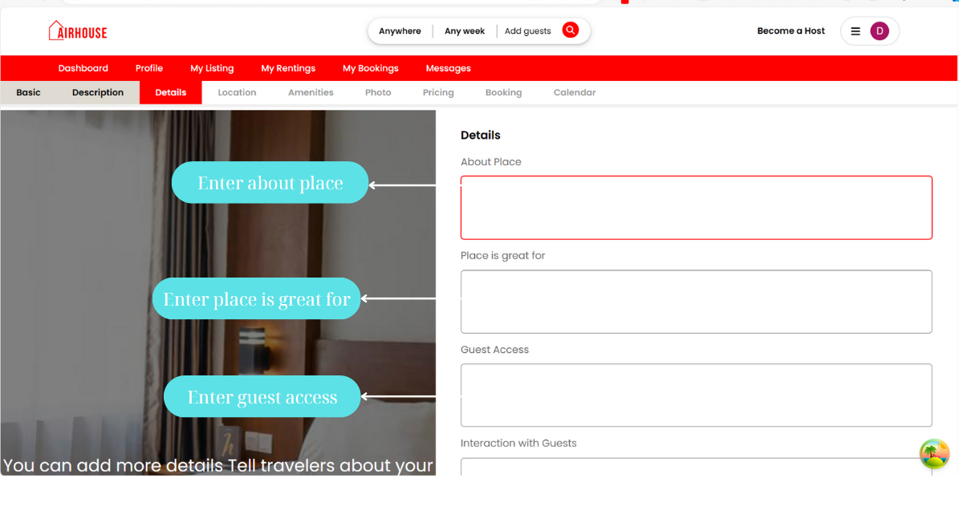

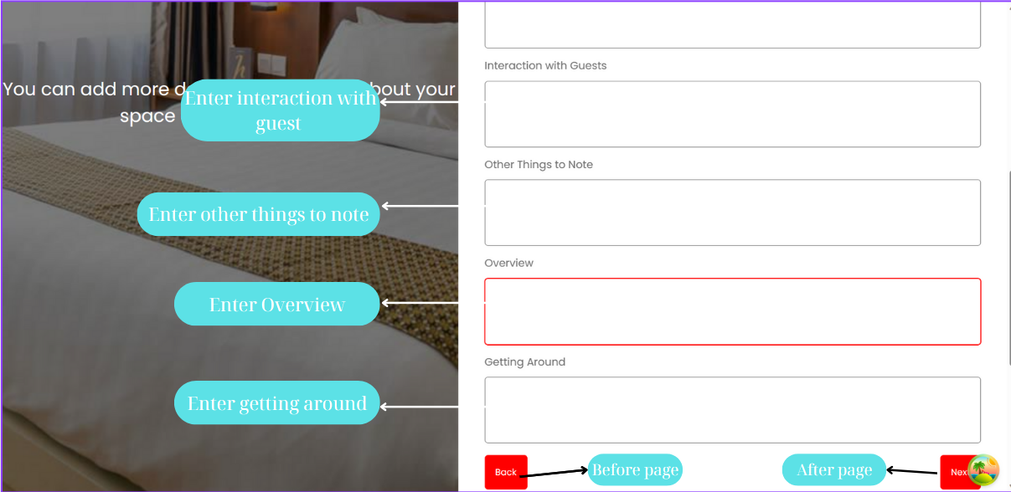

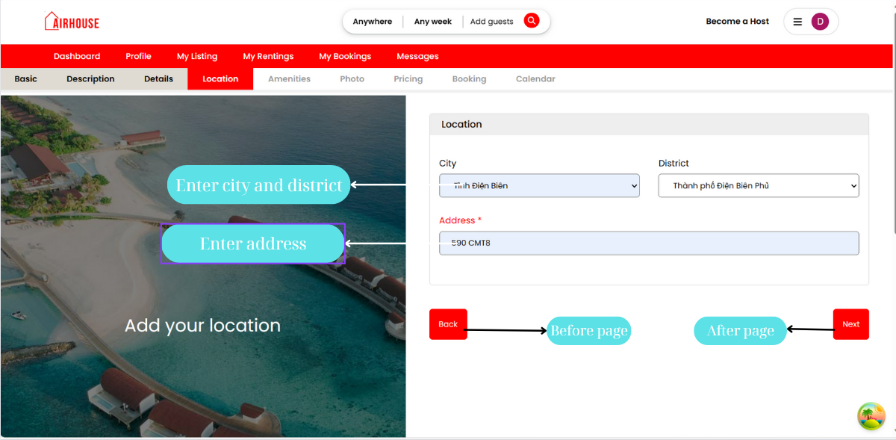

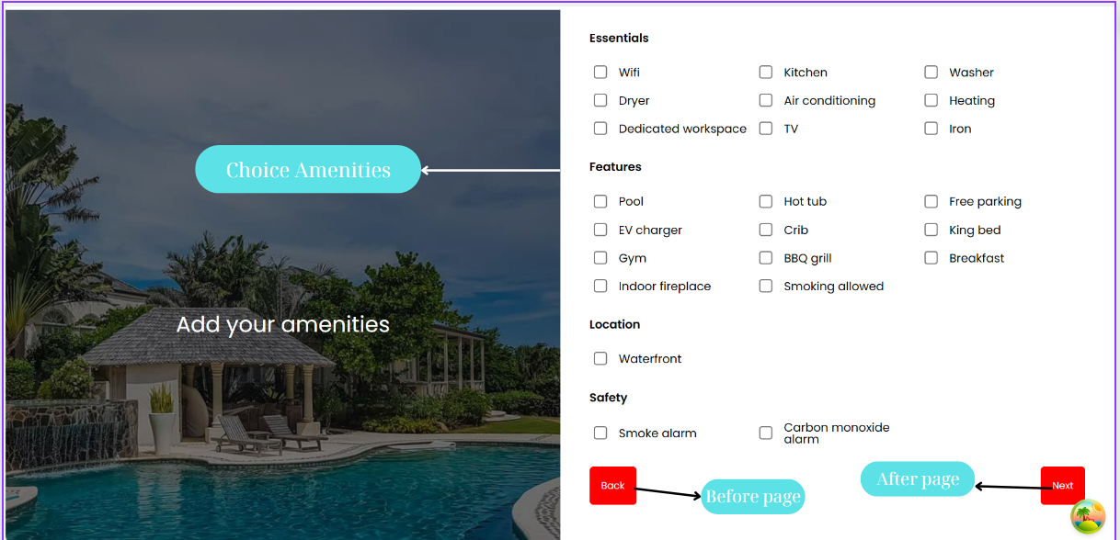

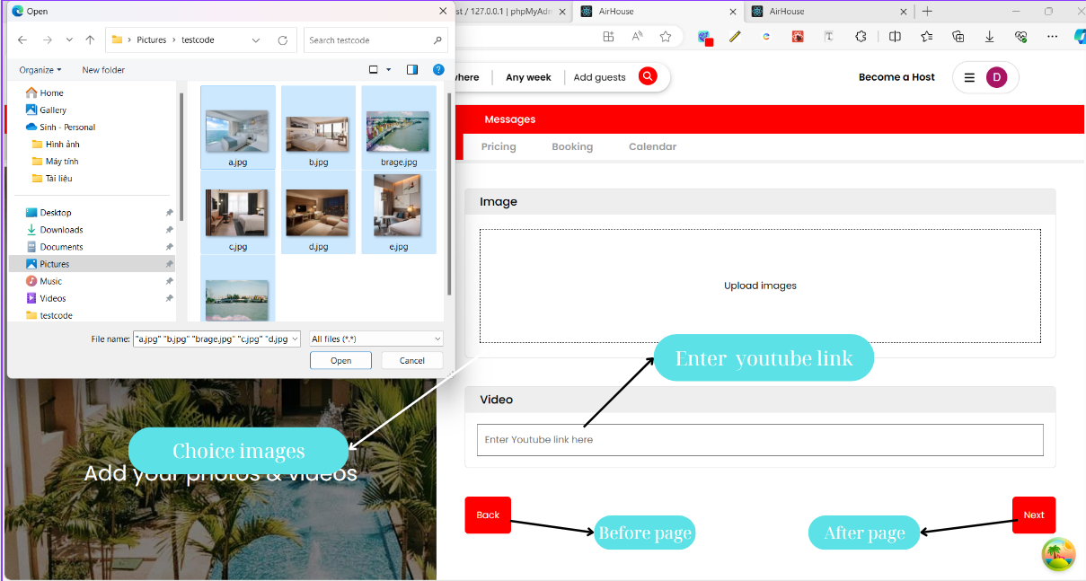

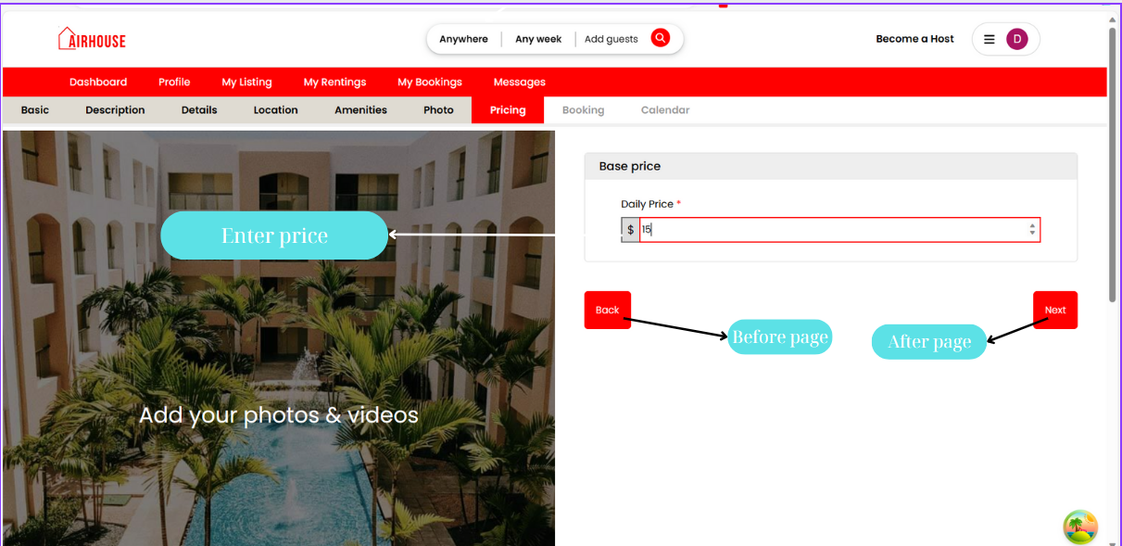

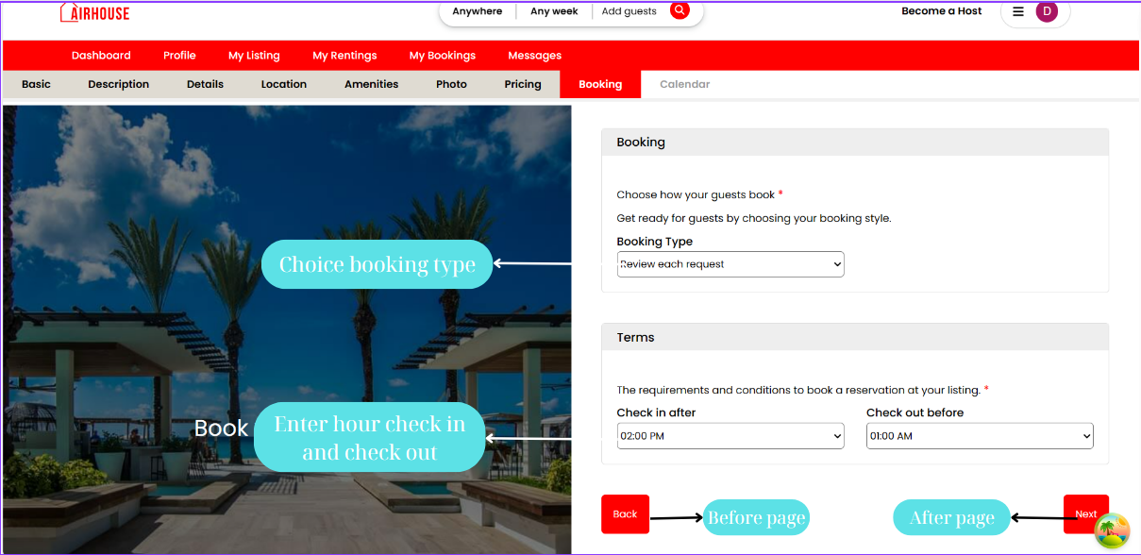

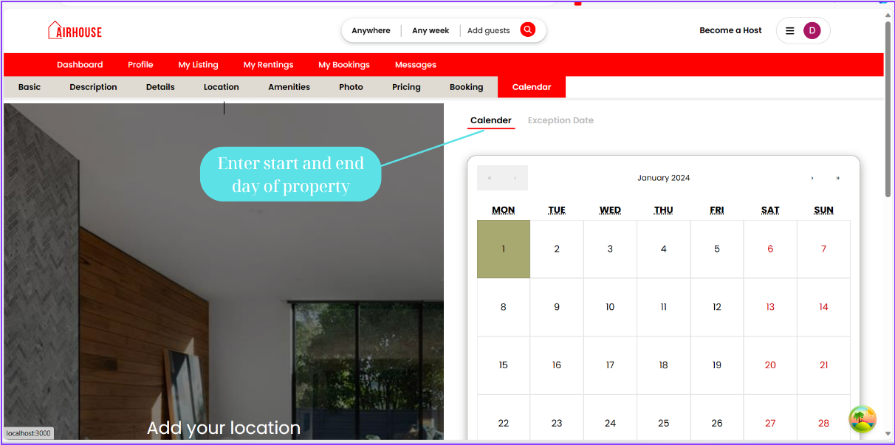

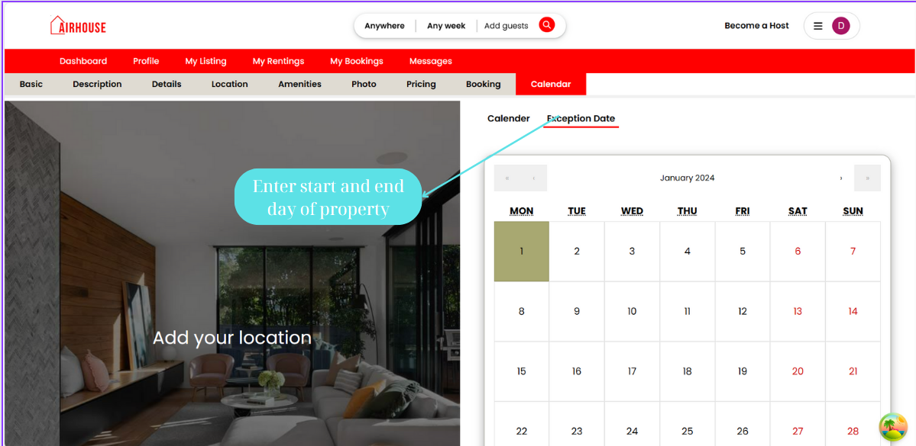

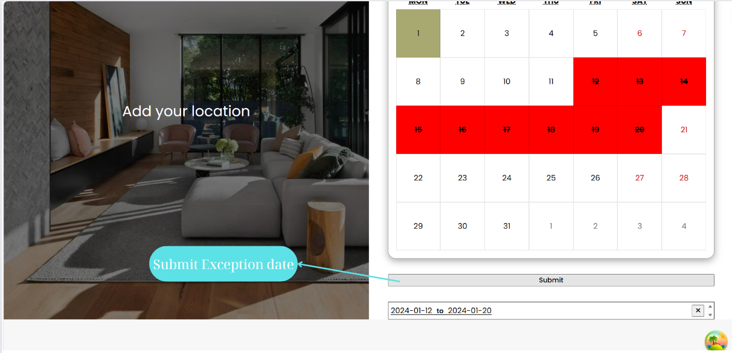

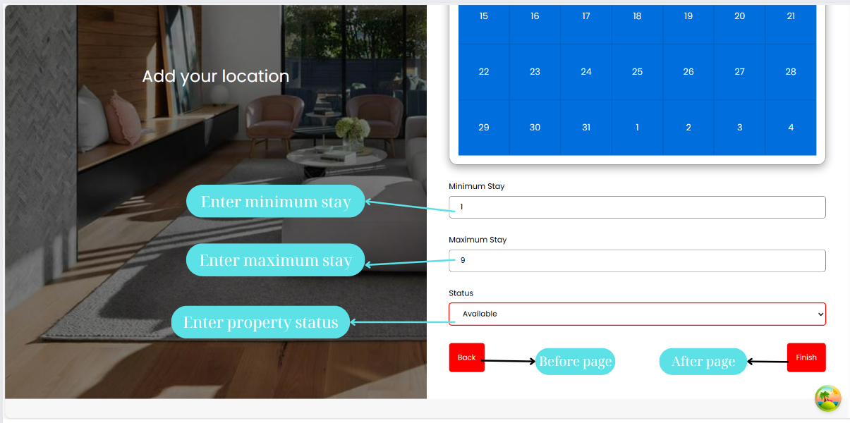

**5. TASK SHEET REVIEW 3**

|  |  |  |  |  |  |  |  |
| --- | --- | --- | --- | --- | --- | --- | --- |
| **Project: Airhouse** | | **Project Name** | **Activity Plan Prepared By** | **Date of Preparation of Activity Plan:** | | | |
| **No** | **Task** | **Actual Start Date** | **Actual Days** | **Team member name** | **Status** |
| **1** | **Database Design** | **Airhouse** | Tân | 15-Dec-23 | 15 | Nhân | Completed |
| **2** | **UI/UX testing** | 15-Dec-23 | 30 | Tân/Mai/Giữ/Nhân | Completed |
| **3** | **Database Seeding** | 15-Dec-23 | 3 | Nhân | Completed |
| **4** | **Admin dashboard** | 15-Dec-23 | 10 | Tân | Completed |
| **5** | **CRUD – Blog** | 15-Dec-23 | 10 | Mai | Completed |
| **6** | **CRUD – Blog Category** | 15-Dec-23 | 10 | Mai | Completed |
| **7** | **CRUD – Property** | 15-Dec-23 | 10 | Mai/Giữ | Completed |
| **8** | **CRUD – Booking** | 15-Dec-23 | 10 | Giữ | Completed |
| **9** | **SendEmail**  **Login by Gmail** | 15-Dec-23 | 7 | Giữ | Completed |
| **10** | **Home page** **Filter** | 15-Dec-23 | 10 | Tân | Completed |
| **11** | **Create Property** | 15-Dec-23 | 1 | Tân/ Mai/Giữ | Completed |

|  |  |  |  |  |  |  |  |
| --- | --- | --- | --- | --- | --- | --- | --- |
| **12** | **Property detail page** |  |  | 15-Dec-23 | 10 | Giữ | Completed |
| **13** | **Login/Register** | 15-Dec-23 | 5 | Tân | Completed |
| **13** | **Admin Layout** | 15-Dec-23 | 15 | Tân/Mai | Completed |
| **15** | **Blog** | 15-Dec-23 | 15 | Mai | Completed |
| **16** | **My Bookings** | 15-Dec-23 | 10 | Nhân | Completed |
| **17** | **Create Booking** | 15-Dec-23 | 10 | Giữ | Completed |
| **18** | **My Rentings** | 15-Dec-23 | 10 | Tân | Completed |
| **19** | **My Listing** | 15-Dec-23 | 10 | Tân | Completed |
| **20** | **Messege** | 15-Dec-23 | 20 | Nhân | Completed |
| **21** | **Dashboard** | 15-Dec-23 | 10 | Mai | Completed |
| **22** | **Profile** | 15-Dec-23 | 10 | Nhân | Completed |
| **23** | **Payment** | 15-Dec-23 | 10 | Giữ | Completed |
| **24** | **Ratings** | 15-Dec-23 | 10 | Tân/Giữ | Completed |

|  |  |
| --- | --- |
| **Signature of Instructor:**  **Ms. Le Mong Thuy** | **Signature of Team Leader:**  **Ngô Đình Tân** |